

[Artificia](https://doi.org/10.1016/j.ailsci.2021.100005)l[IntelligenceintheLifeSciences1(2021)100005](https://doi.org/10.1016/j.ailsci.2021.100005)

|  |  |  |
| --- | --- | --- |
|  | Contentslistsavailableat[ScienceDirect](http://www.ScienceDirect.com) |  |
| ArtificialIntelligenceintheLifeSciences |
| journalhomepage:[www.elsevier.com/locate/ailsci](http://www.elsevier.com/locate/ailsci) |

SignalDetectioninPharmacovigilance:AReviewofInformatics-driven ApproachesfortheDiscoveryofDrug-DrugInteractionSignalsinDifferent DataSources

HebaIbrahima,b,∗,A.Abdoa,AhmedM.ElKerdawyc,d,A.SharafEldina,e

a*DepartmentofInformationSystems,FacultyofComputersandArtificialIntelligence,HelwanUniversity,Egypt* b*EgyptianPharmaceuticalVigilanceCenter,EgyptianDrugAuthority(EDA),Egypt*   
c*DepartmentofPharmaceuticalChemistry,FacultyofPharmacy,CairoUniversity,Egypt*   
d*DepartmentofPharmaceuticalChemistry,FacultyofPharmacy,NewGizaUniversity,Egypt*   
e*FacultyofInformationTechnologyandComputerScience,SinaiUniversity,Egypt*

|  |  |  |
| --- | --- | --- |
| article | info | abstract |
| *Keywords:*  MachineLearning  DataMining  AdverseDrug–DrugInteraction SignalDetection  Pharmacovigilance | | Theobjectiveofthisarticleistoreviewtheapplicationofinformatics-drivenapproachesinthepharmacovigilance fieldwithfocusondrug-druginteraction(DDI)safetysignaldiscoveryusingvariousdatasources.Signalcanbea newsafetyinformationornewaspecttoalreadyknownadversedrugreactionwhichispossiblycausallyrelated toamedication/medicationsthatwarrantsfurtherinvestigationtoacceptorrefute.Signalscanbedetected fromdifferentdatasourcessuchasspontaneousreportingsystem,scientificliterature,biomedicaldatabasesand electronichealthrecords.ThisreviewissubstantiatedbasedonthefactthatDDIsarecontributingtoapublic healthproblemrepresentedin6-30%adversedrugeventoccurrences.Inthisarticle,wereviewinformatics-drivenapproachesappliedbyauthorsfocusingonDDIsignaldetectionusingdifferentdatasources.Theaim ofthisarticleisnottolaboriouslysurveyallPVliterature.Asanalternative,wediscussedinformatics-driven methodsusedtodiscoverDDIsignalsandvariousdatasourcesreinforcedwithinstancesofstudiesfromPV literature.Theadoptionofinformatics-drivenapproachescancomplementandoptimizethepracticeofsafety signaldetection.However,furtherresearchesshouldbecarriedouttoevaluatetheefficiencyofthoseapproaches andtoaddressthelimitationsofexternalvalidation,implementationandadoptioninrealclinicalenvironments andbytheregulatorybodies. |

**1.Introduction**

*1.1.Pharmacovigilancebackground*

DrugsafetymonitoringidentifiedasPharmacovigilance(PV)isfor-mallydefinedbythe“WorldHealthOrganization(WHO)” as“thesci-enceandactivitiesrelatingtothedetection,assessment,understand-ingandpreventionofdrug-relatedproblems” [1].PVmaybeclassified intotwocategories:(1)preauthorizationPVconcerningtheinforma-tionadversedrugeventsaccumulatedfromclinicaltrialsettings(phase 0/IthroughphaseIII)[2];and(2)postmarketing/post-authorizationPV concerningthesafetyinformationcollectedduringpost-authorization lifecycle.Eventhoughpre-authorizationclinicalstudies(i.e.RCTs)are deliberatedasthelineamentofexplainingadrugefficacy,theydon’t usuallydetectwholesafetyconcernsofacertaindrugbeforeitsuse intherealworldduetowell-knownlimitations.Thoselimitationscan besummarizedintherestrictedsampleoftrialparticipantsinvolvedin

∗Corresponding[author.](mailto:pharma_heba@hotmail.com)

*E-mailaddress:*[pharma_heba@hotmail.com](mailto:pharma_heba@hotmail.com)(H.Ibrahim).

thosestudiescomparedtothetotaltargetedpopulationwhomayexperi-encethedrugwhenevermarketed,thelimitedintervalofdrugexposure pereachstudyparticipantespeciallyifthedrugprojectedforchronic use,lackofpossiblyriskypatientsubpopulationswhoareusuallyomit-tedfromclinicaltrials(e.g.,patientswithimpairedorgans,elderlypa-tients,children,andchildbearingwomanwhomaybepregnantorlac-tatingmother,patientsonchemotherapy)[3].Furthermore,RCTscan’t detectrare/veryrareadversedrugreactions(ADRs)(withoccurrences of1/10000and1/100000,respectively)orlatentADRs(*>*6months) [4].Thatsaid,thedrugefficacyinformationfrompremarketingRCTs isgenerallymorecomprehensiveandreliable,whereascompletesafety profilescan’tbeestablished[4].Theseboundariesimposeobligationsof bothmarketingauthorizationholdersandregularityauthoritiestocon-tinuouslymonitor,collect,assess,anddrawconclusionsandappropriate actionstokeeppositivebenefit-riskratioaslongasthedrugexistsin market.

<https://doi.org/10.1016/j.ailsci.2021.100005>  
[Received9March2021;Receivedinrevisedf](https://doi.org/10.1016/j.ailsci.2021.100005)orm26June2021;Accepted27June2021   
Availableonline8July2021   
[2667-3185/© 2021TheAuthors.PublishedbyElsevi](http://creativecommons.org/licenses/by-nc-nd/4.0/)erB.V.ThisisanopenaccessarticleundertheCCBY-NC-NDlicense (<http://creativecommons.org/licenses/by-nc-nd/4.0/>)

*H.Ibrahim,A.Abdo,A.M.ElKerdawyetal.*

*1.2.Drug-druginteractiondetection*

Oneoftheleadingcausesofglobalmorbiditiesandtreatmentfailure isinteractionbetweendrugagents.About30%ofunexpectedadverse drugeventsmaybeaccountedforDrug-druginteractions(DDIs)[5].In acknowledgmentofadversedrugeffectsisachiefreasonofproductat-tritioninlatestagesofthedrugdevelopmentcycle,theearlierdetection oftheinteractionprofilesofnoveldrugcandidatesisstillintractable. Inconventionaldrugdevelopmentprocess,manyofcandidatesofnovel therapeuticsareinvestigatedaforetriagingaslightquantityofeligi-blemolecules,ordinarilydependsonpriorscientists’experienceinthe therapeuticdomainandarenominatedforsubsequentlaboratoryand preclinicaltesting.Regulardrugdiscoveryprocessincludesthedelivery ofnewcandidatesfrombasicmedicinalscientistsintotestinginpre-clinicalphasesfollowedbyaconductionofdifferentclinicaltrials.Un-predictabledruginteractionsmayresultinserioushealthoutcomesand consequentlyundesirableinfluencesonthewholedrugdiscoverypro-gression.Accordingly,anincreasingdemandfordevelopinginformatics-basedframeworkstodiscoversafetycomprehensionintermsofclini-calpracticeandoriginateDDIsofnoveltherapeuticnomineesearlier indrugdevelopmentthroughmultidisciplinarylinkingbetweenclinical andpreclinicalinformation.[6].

Additionally,premarketingclinicalstudiesdon’tusuallyexplore DDIsbutratheremphasizeoninvestigatingtheefficacyandsafetyof individualmedications[7].Sincepatientsonpolypharmacyarenotusu-allyincludedinclinicaltrials.Furthermore,wheneverDDIsaredoubted, samplingbiasesandcohortsizesboundthecapabilityforidentifying rareadversereactions[8].Interactionsbetweendrugsmaytakeplace whensharingthesametargetproteins,pharmacologicalandmetabolic pathwaysleadingtoaffectingthesafetyand/orefficacyprofileofphar-maceuticalproducts.Inothermeans,theco-administrationmayconsid-erablyaffecttheefficacyand/orsafetyprofilesofadrugagent.Un-predictableDDIsarerecognizedonlythroughsignaldetectionprac-ticesandpostmarketinglifecycle[9].ThemagnitudeofaDDIseri-ousnesswarrantsdifferentregulatoryactionsgradingfromlabelinfor-mationchangesintomarketwithdrawals[10–12].Duetothelimita-tionsanddifficultiesinmonitoringinteractionprofilesofdrugs,mul-tipleinformatics-basedresearcheshavebeenemergedinrecentyears forDDIdiscoveryviaadoptingmachinelearning(ML)anddatamining methodsfromheterogeneousdatasources.

DDIscanbeclassifiedbyvariouscriteria.Withregardtoseverity, interactionsarefrequentlycharacterizedbythreecategoriesaccording toseverityinto(minor,moderateandmajor)[13].Thoseinteractions havingminimalclinicalconsequencesandminimalriskareclassifiedas minorDDIs.ModerateDDIiswithmoderateclinicalsignificance,usu-allyavoidthesecombinationsandtheymaybeusedonlyunderspecial circumstanceswithclosermonitoringandmayrequiredosagechanges. MajorDDIiswithhighclinicalsignificanceprobablyleadingtoseri-ousclinicaloutcomesshouldbeavertedduetonegativebenefit-risk ratios.

Intermsofmechanism,DDIsareclassifiedaseitherpharmacody-namic(PD)orpharmacokinetic(PK)[14].ItisnoteworthythatPD–basedDDIsmakeupasmallerclassthanPK-basedDDIs.APharmaco-dynamic(PD)interactionoccurswhenthepharmacologicaleffectofa drugisaffectedbyanotherasaresultof:1)directeffectattargetsite, (2)interferencewithbiologicalorphysiologicalsignalingpathways,re-sultinginadditive,orantagonisticeffects,orsynergistic/indirectphar-macologiceffect[15].Pharmacokinetic(PK)interactionoccurswhena druginfluencesthedispositionofanotherdruginthebodybyinterfering itsabsorption,distribution,metabolism,orelimination(ADME)proper-ties,causinganalteredplasmaconcentrationofthefirstdrugthatmay leadtodetrimentalconsequences(treatmentfailureortoxicity).Within thepharmacokineticprocesses,themetabolismpartcoversthelargest [16].Arecentstudy[17]hasestimatedthatthePK-basedDDIsoccurat metaboliclevelasfollows:(i)64%ofPK-relatedDDIsinvolveinduction orinhibitionofthehepaticcytochromesthatareaccountableformedi-

2

*H.Ibrahim,A.Abdo,A.M.ElKerdawyetal.*

**2.WidespreaddatasourcesinsupportofPharmacovigilance**

*2.1.PostmarketingPharmacovigilanceData:Spontaneousreporting systems*

PostmarketingPVdataaremainlyavailableinseveraluniquedata sourcesthroughSpontaneousreportingsystems(SRSs).Thistypeof spontaneousdataisthemainsourceforpostmarketingmonitoringun-tilnow.SRSsarelargedatabasesforcollectingindividualcasesafety reports(ICSRs)ofsuspectedadverseeventspassivelyreportedtoreg-ulatoryauthoritiesbypatients,healthcareprofessionals,andindustry. TheVigiBase(theWHO-UMCglobaldatabaseofICSRs)[19],USFood andDrugAdministration(FDA)adverseeventreportingsystem(FAERS) [20,21],theEuropeanEudraVigilance[22],andthe“vaccineadverse eventreportingsystems(VAERS)” [23]arethemostprominentICSRs managementsystems.

SuchkindofSRSsaredevelopedtoenablecontinuousmonitoringof pharmaceuticalandbiologicalproductswithinpharmacovigilancesys-tems[24].Generally,thestructureofSRSsadherestotheinternational safetyreportingguidanceissuedbytheInternationalConferenceonHar-monisation(ICHE2B)thatsetsstandardsforreportingindividualcase safetyreports(ICSR)[25].OthertypeofSRSsistheproprietarycom-panysafetydatabasesthatcontainICSRsofacompanypharmaceutical products.Theycansupportearlysafetysignaldetection.Themeritsof SRSsarerepresentedinprovidinginformationnecessaryforestablishing causalityassessmentfromrealdataand/ordevelopingmining/MLmod-elsthatmightnotbeavailableinotherdatasources.Forexamplebut notlimitedto,apparenttemporaltimerelationship,concomitantmed-ications,indications,de-/re-challengeinformation,somedemographic patientdata,andactiontaken&outcomeInformation.Despitemulti-benefitsofSRSswhichplayingacrucialroletosupportwisetherapeu-ticdecision-makinginregulatorybodies,theyhavewell-knownbound-aries.Thoselimitationscanbesummarizedinover-/under-reporting rates,limitedpastmedicalhistoryofpatients,falsesignalingduetomis-attributiontohiddenconfounders/riskfactors,andinabilitytoindicate realincidencerates.

*2.2.ElectronicHealthcareData*

Electronichealthcaredataconsistsofmultiplesourceslikeelectronic healthrecords(EHRs),administrativeandinsuranceclaimsdatabases. EHRsareakindoflongitudinalobservationalsystemswherepatients’medicalrecordsarecreatedfrommultiplesystemsinhealthcareor-ganization(s).ManyoftheEHRfieldsarecomposedofunstructured data(e.g.dischargesummaries,labtestfindings,nursenotifications, etc.)andnon-specificadverseevents.Naturallanguageprocessing(NLP) studiesshowhowusingEHRsdataviaadoptingtextminingapproaches canbebeneficialforextracting,encoding,anddetectingsafetysignals [26–29].ThemainbenefitofEHRsfromtheaspectofPVistheircapabil-itytoconductactivesurveillancefromreal-workdata[30–32].Merits distinguishEHRsystemsfromSRSscanrepresentedin:notcontaining duplicates,largelyunaffectedbyunder-orover-reportingastheytyp-icallyderivedautomatically,providingconsistentinformationonmost ofthesubject’sdrugexposureperiods,clinicallyrelevantevents(inde-pendentlyfromtheexposurestatus)andvaluableinformationonex-posedsubjectswithoutevents,andmuchmorecompleteassessment ofdrugexposureandcomorbiditystatus.Forthat,EHRsystemsmay generatesafetysignalsearlierthanSRSs.Nevertheless,theabovemen-tionedlimitationsconsiderthekeyboundariesforapplyinginregular PV.Otherlimitationscanberepresentedin:difficultytoaccessdueto privacyissues,andverychallengingpolicyandtechnicalissuestointe-grateEHRsfrommultiplesources.InEHRs,elevatedratesofamedical diagnosismayindicateasafetyissue(ifsubsequenttoprescription),so somestudieshavehypothesizedthatmetricsbasedonexploringlongi-tudinalobservationaldatasetfortemporalassociationsbetweenevents overtimeratherthanperson-countscouldproducemoreaccurateas-

3

*H.Ibrahim,A.Abdo,A.M.ElKerdawyetal.*

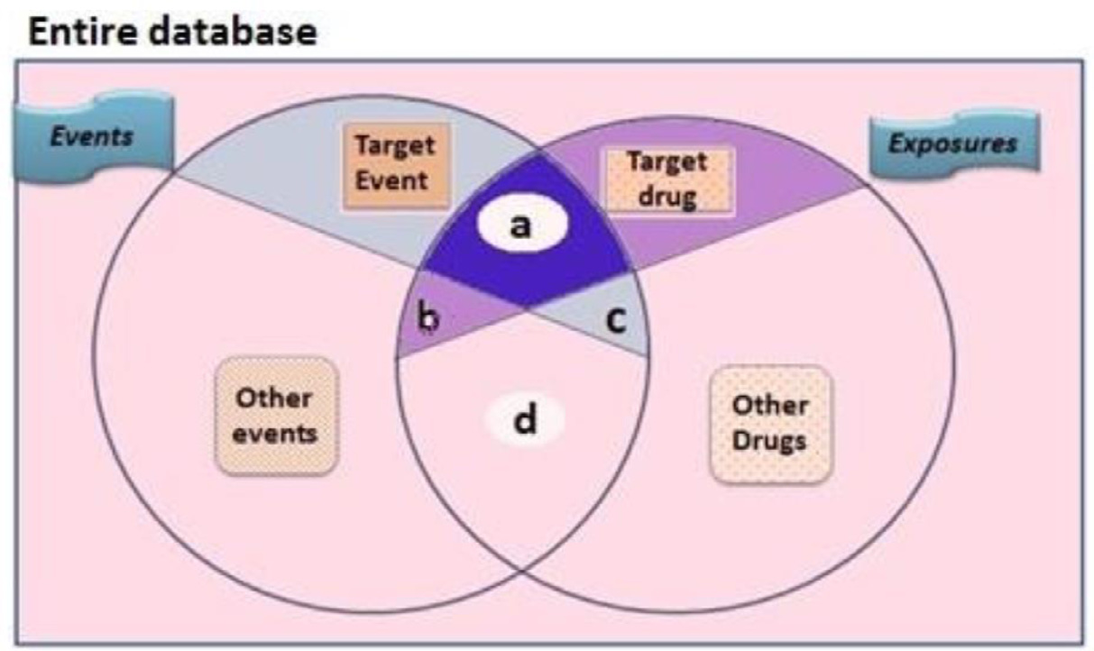

*ArtificialIntelligenceintheLifeSciences1(2021)100005*

**Fig.1.VennDiagramillustratingtheentries{a,b,c,d}ofcon-tingencytable.**a,numberofreportscontainingboththesuspect drugandthesuspectadverseevent;b,numberofreportscontaining thesuspectdrugwithotheradverseevents(excepttheeventofin-terest);c,numberofreportscontainingthetargetadverseeventwith othermedications(exceptthedrugofinterest);d,numberofreports containingothermedicationsandotheradverseevents.

|  |  |
| --- | --- |
| categorizedintotwogeneralclasses(frequentistandBayesian).Both categoriesutilizetheentriesofconfusionmatrix(asshownFig.1)to computethemagnitudeofstatisticalassociationbetweendrug-adverse-eventcombinations(DECs)inaPVdatabase[46].Theirprinciples dependonestimatingobserved-to-expectedreportingratiosfordrug-reactionpairsusingthetotalnumberofcasesinbackground[47–52]. Theyquantifytheunexpectednessofadverseeventbeingreportedto adrugordrugpair.AllDPAssharethesamebasicofdisproportion-atereportingbetweenobservedtoexpectedratios,despitetheydiffer incomputationpereach.WheneveraDEC’sDPAcomputationexceeds thepredefinedminimumthresholds,itwillbeflaggedasastatistical safetysignalthatrequiresfurtherclinicalassessment.Differentthresh-oldsareusedforthesealgorithmstoidentifysignificantsafetysignalsfor DECs.  *3.2.AssociationRuleMining*  BesidesDPAs,thereisanalgorithmcalled*associationrulemining* (abbreviatedasARM)[53].ARMisconsideredawell-knownmin-ingalgorithmfordisclosinginterestingpatternsconcealedwithinlarge databases.Thisalgorithmwasfirstadvancedsincemorethanadecade tobeappliedtothefieldofcomputerscience,thenexpandedtovarious sciences[54–56].SomestudieshaveadoptedARM-basedalgorithmsto detectadverseDDIpatternsusingSRSs[57].Apriorialgorithmisakind ofassociationrulesminingwhichoffersanappropriaterepresentation ofsparsedataforcomplexcomputations[53].Anyassociationrulecan beexpressedintheformof*𝑥*→ *𝑦*where*x*isanelementfromXitem-set,while*y*isanelementfromYitemset,notingthatx&yaredifferent items.Toestimatedirectionality,thegeneralApriorialgorithmworksin twosteps.Thekeyofprimarystepisbuiltoncountingafrequentitem setwhenanobservedassociationbetweenitemsexceedsthesupport threshold.Whilethesecondstepdependsongeneratingconfidentasso-ciationrulesfulfillingpredefinedminimumthresholds.Fromthescope ofPV,*𝑋* symbolizesanitemsetofmedicationsandysymbolizesanitem-setofadverse-reactions.Asignificantassociationruleindicatesthata specificDECexceedsminimumthresholdsofminimumconfidenceand support.ThesupportofaDEC*𝑆*(*𝑋*)istheobservednumeralsofreports having*𝑋*.Whilesupportofanassociationrule*𝑆*(*𝑋*→ *𝑌*)canbesym-bolizedas*𝑆*(*𝑋*∪ *𝑌*).Theconfidenceofanassociationrule*𝐶*(*𝑋*→ *𝑌*) indicates(*𝑆*(*𝑋*∪ *𝑌*))∕(*𝑆*(*𝑋*))(**1**).Confidencedefineshowfrequently objectsinYrepresentedinreportscontainingX.Confidenceenablesthe estimationofconditionallikelihood(*𝑃𝑟*(*𝑌*)∕(*𝑋*))(**2**)ofYinpresenceof X.Aninterestingassociationisflaggedwhenarulefulfillstheminimum thresholdsofbothsupport&confidence,howeversomestudieshave suggestedothermeasurestofiltersignificantDDIassociations[53]. | *3.3.Regression-basedApproaches*  Confoundersarehiddencovariatesthatmaybehiddenfactorslead-ingtoeitherflaggingspurioussafetysignalsordelayingthedetection ofsignificantones[58].Itisworthmentioningthatconfoundersmay inferariskfactorpredisposingtheadversereactionorakeytoidentify higherriskypatientsubpopulations.Asimplertypeofconfounderscan beseeninvariables(forexample,age,gender,andyear).Theymaybe handledeffectivelybythestratificationforeachstratumusingMantel–Haenszeladjustments[59,60].Nevertheless,adjustinghugenumeralsof possibleconfoundersmayresultinmissingsignaldetectioninatimely manner[61–63].Anotherlimitationisrepresentedinstratificationby gender,age-group,etc.wherethenumberofcasereportsarelowand theninfeasibletoconductsubgroupanalyses.Additionally,thereare otherformsofconfounderscalled“innocentbystander” responsiblefor theoccurrenceofadverseeventssuchasinteractingdrugsorindica-tionsofreportedcomedications.Unfortunately,usingMantel–Haenszel approachesforadjustingsuchkindofconfoundersisineffective[60]. Forlargenumbersofcovariates,adoptinglogistic-regression(LR)ap-proachismoreefficient[61].  LRextendslinearregressionfunctionbyasigmoidfunctiontoavalue intervalfrom0to1[62].LRcomputesRORbycategorizingdatabase’s recordsascase-controlrecordswhereacaseiscountedwheneverhav-ingadverse-eventofinterest,whereascontrolsarecountedwhenever recordshavingotheradverse-events.InthecontextofPV,twostudies havereportedadoptingLRmodelingusingSRSsaimingatDDIsignalde-tection[63,64].ThecomprehensionofLRcanbeexpressedaccording tothefollowingformula:  *̂𝑦*=*̂𝑝* ( *𝑥*1*,𝑥*2 ) =log*𝑝* 1−*𝑝*=*̂𝛽*0+*̂𝛽*1*𝑥*1+*̂𝛽𝑛𝑥𝑛*  (3)  Where*̂𝑦*denotespredictedoutcome;*̂𝛽*0=coefficientofslope; x0=Slope;*𝛽*n=coefficientofcovariatesn,Xn=numberofpredic-torsorfeaturescovariates.  **4.Paradigmsofdataminingandtextminingstudiesusing spontaneousreportingsystemsfordetectingDDIsignals**  Neverthelessthelimitationsofany“spontaneousreportingsystem (SRS)” inregularPVpractices,SRSsprovideprecioustoolindetecting previouslyunknownsafetyconcerns[65].DPAsrepresentthemostcom-monlyappliedalgorithmsintheareaofquantitativesignaldetection withinhealthauthoritiesandlargepharmaceuticalindustry[66,67]. TheShrinkagemeasureΩ,whichistheextensionofICmeasurefor thetriplets{drug-drug-AE},hasbeeninnovatedbyNorén*etal*.atUp-psalamonitoringCentre(UMC)toscreenpotentialDDIsignalsinthe |

4

*H.Ibrahim,A.Abdo,A.M.ElKerdawyetal.*

VigiBase[9].AuthorshaveshowntheprivilegesofΩ shrinkagemea-surecomparedtologisticregressionindetectinginterestingpatternsof DDIsignals.Itcanbecalculatedbyestimatingtheproportionbetween observedandexpectedfrequenciesasseeninthefollowingequation;

|  |  |  |
| --- | --- | --- |
| Ω =*𝑙𝑜𝑔*2 | *𝑛*111+*𝛼*  *𝐸*111+*𝛼* | (4) |
| WhereE111standsforthe“expected” incidencevalueofdrug-drug-eventcombinationwithinaPVdatabase;aisaconstantequalsto0.5; Ω025isthelowerboundaryof95%confidenceintervalwhichflaga statisticalDDIsignalwhenitsvalue≥0[9].In2013,Choi*etal.*have investigatedthefeasibilityofusingthenationalKoreanhealthinsurance systemnamed“HIRA” inidentifyingDDIsignals[68].Theyadopted theshrinkagemeasureOmegaΩ ontheICD-10codesofdiagnosesin associationwithastandardDDIdatasetofNSAIDanddiuretics.  AReportingratios(RR)wasused,asaconditionaldisproportionality analysis,toassesstheincreasedofuserssearchingforhyperglycemia-relatedtermsgiventhattheysearchedforbothpravastatinandparox-etine.Theresultsprovidedevidencetothepotentialityofpredictionof drugsafetysignalsfromsearchlogs.  Almenoff *etal*.haveexaminedtheBayesiandisproportionalitymea-sureMGPS(90%confidenceinterval)inscreeninginteractionprofiles betweenantihypertensivedrug“verapamil” andotherclassesofcar-diovascularmedications[69].Resultshaveshowntheusefulnessof MGPSdisproportionalityalgorithminminingDDIinterestingpatterns inpolypharmacyconditions.Schuemie*etal.*[70]proposedanapproach knownaslongitudinalGPS(LGPS)whichisamodificationoftheorig-inalMGPSapproach.LGPScomputedtheexpectednumberofmedi-caleventsduringdrugprescriptionsbasedonanaggregateunexposed patient-timeinexposedandunexposedpatients.Forprotectingagainst confoundingfromdominatingunexposedpatientssolongasthemajor-ityofthepatientsinapopulationdon’treceivespecificmedicine,au-thorssuggestedafilternamedObservationalProfilesofAdverseevents RelatedtoDrugs(LEOPARD)toeliminatespuriousassociationscaused byprotopathicbias.LGPShasbeenshowntooutperformrelatedmeth-ods,includingMGPS.  In2010,Harpaz*etal.*[71]haveproposedanenhancedApriorial-gorithmusingFAERSdataforthepurposeofdetectinginterestingDDI patterns.BecauseoftheunsuitabilityofclassicApriorimetricsfordrug safetyfield,RRRmeasurewasutilizedinstead,withsupplementaryfil-terthateachdrugpairinassociationtripletshouldhaveRRRscore higherthananyofeachdrugindividually.Thesecondfiltercriterion wasaimedtoeliminatespuriousDDIsignals.Resultsexhibitednearly 35%ofthedrug-drug-reactionassociationsrelatingtowell-knownDDI, thusindicatingtheprobablebenefitofcustomARMinflaggingpoten-tialDDIsignalsthatwarrantfurtherclinicalassessment.Anotherstudy, Ibrahim,H*etal*.[72]havepresentedanaugmenteddataminingal-gorithm“hybridApriori”,customizedtoPVapplications,wheredis-proportionalityPRRmeasurewasadoptedasinterestingnessmeasure todiscoverassociationpatternsofadverseDDIsfromFAERSdata.On theotherside,VanPuijenbroek*etal.*[73]haveconsideredanadjusted disproportionalitymeasureRORthroughimplementingamodeloflo-gisticregressionontheNetherlands’sPVdatabase“LAREB” toevalu-atetheadverseeffectsforthecoadministrationof“non-steroidalanti-inflammatorydrugs(NSAID)” and“diuretics” onworseningthesymp-tomsofcongestiveheartfailure(CHF)disease.Resultsimpliedthatus-ingNSAIDsthemselveshasnoroleinincreasingtheriskofCHF.While uponcoadministrationwithdiuretics,NSAIDshavecontributoryrolein aggravatingCHF.TheauthorshaveconcludedthatadoptingLRcanof-feradvantagesoverbivariatedisproportionalitymeasuresviaguarding againstfalsesignalsasaresultofconfoundingbyconcomitantmedica-tions.  Thakrar*etal*.haveillustratedtheprincipalofmultiplicativeandad-ditivemodelingindiscoveringDDIsignalsusingSRS[74].Thedesign ofmultiplicative/additiveframeworkwasbuiltonestimatingtheinter-actioncoefficient(*𝛿*)wheretheassociatedriskwithdrugpaircoadmin- | | |

5

*H.Ibrahim,A.Abdo,A.M.ElKerdawyetal.*

dardofknowninteractionsfromDrugBankandtheMediSpan® Drug TherapyMonitoringSystemTM(WoltersKluwerHealth,Indianapolis, IN).Inoverall,authors’methodachieved81.5%areaundertheReceiver OperatorCharacteristic(ROC)curveforsignalingknownDDIs.

Segura*etal*.[78]proposedtheshallowlinguistickerneltechnique forautomaticDDIsextractionfrombiomedicaltexts.Astherecogni-tionofdrugnamesisanessentialprerequisitestepfortheautomatic discoveryofDDIsfrombiomedicaltexts,authorsusedUMLSMetaMap Transfer(MMTx)tooltoautomaticallyidentifydrugentitiesoccurring inunstructuredtextualdocumentsofDDIsfromDrugBankdatabase. TheMMTxrecognizesandannotatesdrugentitiesaccordingtoUMLS semantictypes(e.g.,ClinicalDrug[clnd],PharmacologicalSubstance [phsu],andAntibiotic[antb]).Drug-DDIcorpuswascreated,annotated with3169DDIs,astheoutputofMMTxinXMLformat.Also,MMTx toolwasusedtoextractandlabelcandidatesofdrugpairswith1ifin-teractionexistsorlabeled0ifnointeractionexists.Theperformance ofproposedshallowlinguistickernel-basedtechnique,withaprecision of51.03%,arecallof72.82%andanF-measureof60.01%,confirmed theremarkableimpactofautomaticentityrecognitionontherelation extractiontask.

In2013,White*etal*.[79]havedemonstratedthattheinternetsearch logsthataregeneratedbyconsumersareabletoprovideearlyclues aboutDIAEs.Theauthorsconductedalargescalestudyofwebsearch logpayingattentiononspecificinteractionbetweenparoxetine(anan-tidepressant)andpravastatin(acholesterol-loweringdrug),whichwas recentlyreportedin2011tocausehyperglycemia.Yang*etal*.[80]pro-posedatextminingmethodologywheretheyusedsocialmediatoiden-tifyDDIpatternsbycombiningARMandlexicon-basedalgorithms.The authorsusedadatasourcecalled“MedHelp” asanexampleforanon-linehealthcareforums.Onlytripletswereconsideredwhereaseachco-occurrencewascountedforapairofinteractingdrugsassociatedwith anadverseevent.Theyexaminedthesignificanceoftheconstructed drug-drug-adverse-eventassociationsusing4metricsasfollows{sup-port,leverage,lift,andconfidence}[81].Somelimitationsrelatedto thepreviousmentionedmeasuresforexample,theleveragecouldbe verysmallorevennegativebecauseoftheverysmallofthreadsrelated toADRcomparedwiththetotalnumberofthreads.Forthat,authors adoptedanothermeasurecalledinteractionratiotocaptureDDIsignals throughwhichvariationofconfidencecanbecalculated.Thegenerated patternshaveproventhefeasibilityoftheproposedapproachinDDI signaldetectionfromDrugBankdatabase.

**5.Machinelearningapproachesforthepredictionofsafety signals**

Inrecentyears,researcheffortshavedirectedfromdataminingap-proachestowardsmachine-learning(ML)todiscoverDDIsearlyduring thedrugdiscoveryprocessbeforebecomingcommerciallyavailable.ML methodscanbecharacterizedintotwobroadcategories:supervisedand unsupervised[82].Insupervisedlearning,amodelisbuiltpriortothe analysiswherethemodellearnsfromlabeledinputdatainordertoesti-matespecificrelationshipsbetweenthefeaturesandthelabelsofthein-putdata.Then,thelearnedmodelisappliedtounseendatatopredictthe categoryorquantityofinterest.Classificationandregressionarevery commonsupervisedlearningtechniquesusedinbiomedicalresearch.It isworthmentioningthatregression-basedapproachesaretraditionally adoptedforeitherbiostatisticsordataminingpurposesasillustratedin section4.However,inseveralstudieseitherlinearorlogisticregression areconsideredasMLmodelsforbinary/multi-classpredictionofcon-tinuous/categoricalfeatures.SupervisedMLalgorithmsmaybeusedfor featureselection,classification,predictionorevaluatingtheefficiency ofsomeparameters[83].Incontrast,forunsupervisedlearning,theal-gorithmisapplieddirectlyonunlabeledinputdatatofindregularities, andthenamodelwillbebuiltaccordingtotheidentifiedpatterns.Clus-teringandbiclusteringalgorithmsarethemostcommonunsupervised MLtechniques[84].Thefollowingsubsectionsfrom5.1through5.5

6

*H.Ibrahim,A.Abdo,A.M.ElKerdawyetal.*

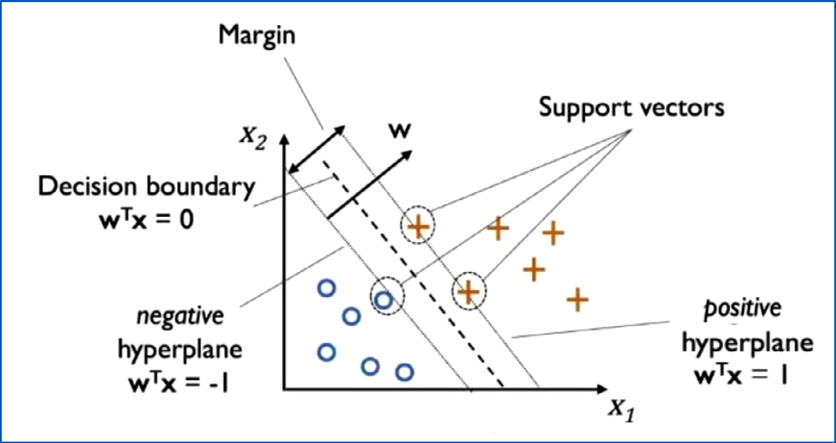

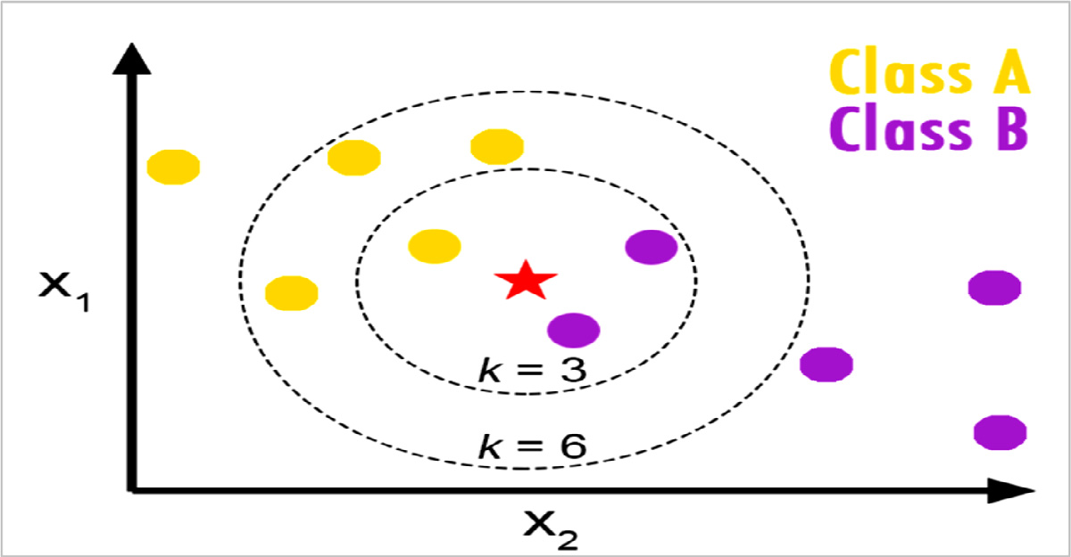

*ArtificialIntelligenceintheLifeSciences1(2021)100005*

**Fig.2.Schematicrepresentationoflinearsupportvectorma-chinealgorithmconcept**.The*𝜔*denotesthenormalizedvectortothe decisionhyperplane;Horizontalandverticalaxes(X1andX2)symbol-izethefeaturespace(feature1&feature2).

**Fig.3.**Schematicrepresentationofk-NearestNeighbor(KNN)algo-rithmconcept.Where,k=numberofneighbors;X1&X2aretheinput descriptors;Redstaristhequeryinstance[89].

|  |  |
| --- | --- |
| ThemainadvantageofKNNalgorithmisitscapabilitytoarbitrar-ilyapproximateanydatadistribution.Howeveritsdemeritscanbe abridgedasfollows:(i)ComputationallychallengingasKNNusesall datapointsoftheloadedtrainingdatasetforconductingqueries;(ii)the numberofdataneededtobescaledgrowsexponentiallywithdimension byincreasingthedatasetsize.Itisknownasthe“curseofdimensional-ity”.  *5.3.RandomForestClassifier*  Ensemblelearningisageneralmeta-approachthatcombinespredic-tionsfrommultipleMLmodelstoachievebetterpredictiveperformance. OneofthepowerfulMLalgorithmbasedonbaggingensemblelearning israndomforestclassifier(abbreviatedas“RFC”).Itwasdevelopedby LeoBreiman[92].Baggingisoneofthemainstandardstrategiesusedin ensemblelearningtechniquesthatfitsmanydecisiontreesondifferent samplesofthesamedatasetandaveragesthepredictions(seeFig.4) [93].  RFCisasupervisedlearningalgorithmthatisbasedontheinfras-tructureofdecisiontreealgorithmandtoclassifyeithercategoricalor continuousfeatures[94].Itestimatesnumbersofdecisiontreeclassi-fierswhichfitonvarioussubsetsofatrainingdatasettoaugmentthe predictiveperformanceandmanageoverfittingcomparedto“Decision treealgorithm” (refertoFig.5).Theconsiderednumberoffeaturesat eachsub-treeequalstothesquarerootofthenumberoffeaturesinthe inputtrainingdataset.Then,itaveragesthescoresofeachdecisiontree topredicttheclassofthetestdatasetinstance[95,96].  Besidesthehighvarianceassociatedwithtreeclassifiersduetosub-stantialchangeinthetrainingdatasetresultinginverydifferentsub-treesandbeingnon-interpretable,RFCisstillprivilegedasarelatively fasttrainingmodelthatrequireslittledatapreparationcanbeadopted formultidimensionalproblems[97,98]. | *5.4.ArtificialNeuralNetworks*  ArtificialNeuralNetworks(ANN)areasetofalgorithmsdeveloped toimitatetheneuronsinhumanbrainthataredesignedtorecognize patternsindatawhichmaybeusedforclassificationorclusteringprob-lems[99,100].TherearetwomaincategoriesofANN:(i)simpleneural networks;(ii)deeplearningneuralnetworks(refertoFig.6).Wehere outlinethegeneralANNarchitecturesandcommonactivationfunctions withtakingintoconsiderationdeeplearningneuralnetworksareoutof scopeoftheunderlyingreviewwhereANNs.  TherearetwospecificarchitecturesforANNs:(1)Feed-forwardneu-ralnetworksand(2)Feedback/Recurrentneuralnetworks.*Feed-forward neuralnetworks*arethemostcommonarchitectureofANNinpractical applications.Inthisarchitecture,theinformationtravelsinonedirec-tiontowardstheoutputlayerwithoneormultiplehiddenlayers.While *Feedback/recurrentneuralnetworks(RNNs)*aremoreflexibleandmuch difficulttoanalyzethanfeed-forwardnetworks.RNNscanprocessvari-ablelengthinputsbyprocessingthemintimesteps,allowingtheoutput ofdeeperlayerstobefedbacktopreviouslayersinsubsequenttime steps.ThereforethistypeofANNistypicallyutilizedinsequentialand time-seriestasks.  Fig.7showsschemeofaninterfacialneuronwhereasequenceof threeoperationscanberepresentedasfollows:(1)takeaninputfeature *𝑖*foravector*𝑋* andassignitaweight,thensumthoseinputstoobtain modulatedfeaturescomingtothebodyoftheneuron,andfinallyhave anactivationfunction*𝑓* “*Perceptron*” thattransformsthosemodulated featuresintotheultimateoutput/class[96].  Therearevarioustypesofactivationfunctionsbutthemostcom-mononesusedinANNmodelingareHeavisidestepfunction[101],Sig-moidfunction[102],HyperbolicTangentfunction(Tanh)[103],Recti-fiedLinearUnit(ReLU)[104],Softmaxfunction[105].Heavisidestep functionistheclassicandsimplestANNactivationfunctionwithbi- |

7

*H.Ibrahim,A.Abdo,A.M.ElKerdawyetal.*  *ArtificialIntelligenceintheLifeSciences1(2021)100005*

**Fig.4.**Schematicrepresentationofbag-

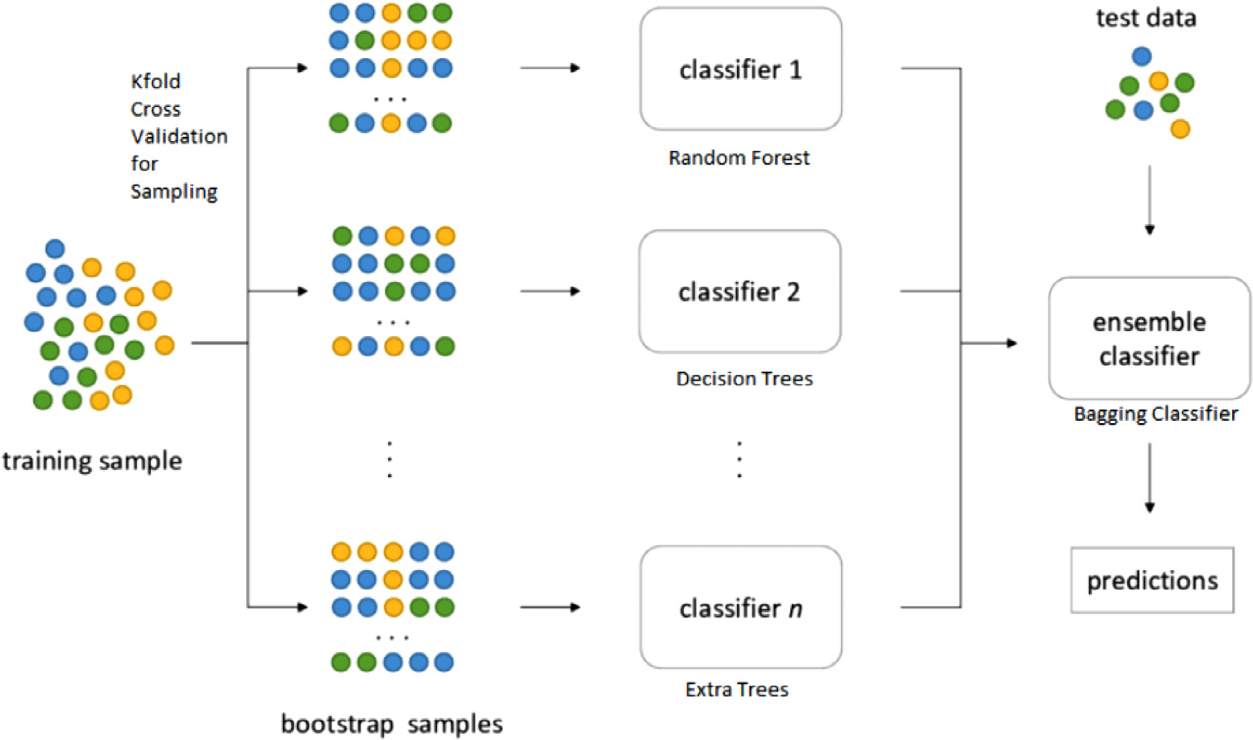

gingensemblelearningconcept.

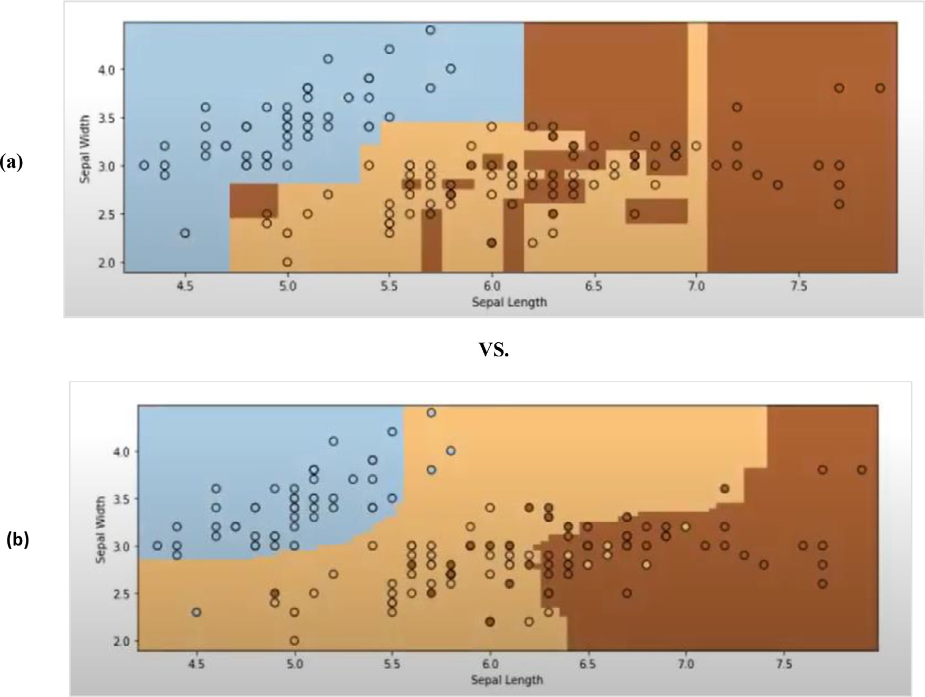

**Fig.5.**Comparisonof(a)decisionboundariesofdecisiontreeclassifierversus(b)decisionboundariesofrandomforestclassifieronclassicexample“Irisdataset”.

naryoutcomethatwasfirstdevelopedbyFrankRosenblatt(Referto the“bluecircle” inFig.7above).Itoutputs0ifthescoreis≤0,and1 otherwise.

Sigmoidisanon-linearactivationfunctionwhichisalsoknownas“Logisticfunction”.Itprovidesasmoothanddifferentiatedgradient curve.Sigmoidistypicallyusedastheactivationfunctioninbinary classificationproblemswhereitspredictionoutputisnormalizedinto therange[0–1].LikeSigmoid,Hyperbolictangentactivationfunction isusedinbinaryclassificationproblems.Nonetheless,itiszerocentric

8

*H.Ibrahim,A.Abdo,A.M.ElKerdawyetal.*  *ArtificialIntelligenceintheLifeSciences1(2021)100005*

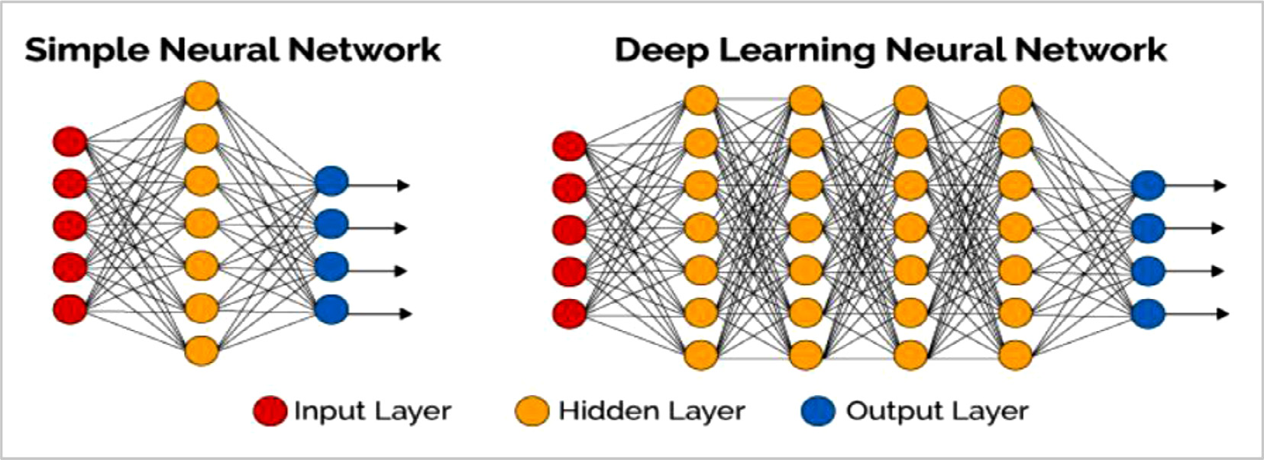

**Fig.6.**Maintypesofartificialneuralnetworks(ANN).

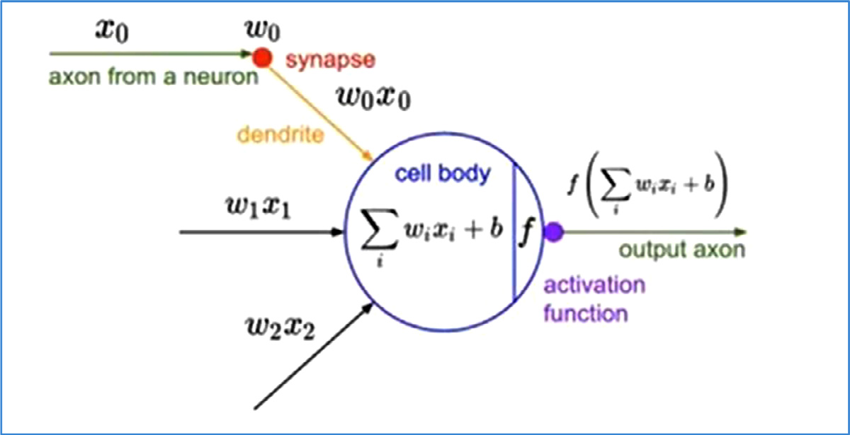

**Fig.7.**Schematicrepresentationof“Perceptronlearningrule” toim-itateanartificialneurontobiologicalneuron.*𝑋𝑖*:Inputfeatureito avector*𝑋*inasingleneuron;*𝑊𝑖*:assignedweightforeachinput featurei.

|  |  |
| --- | --- |
| *5.5.NaiveBayes*  NaiveBayes(NB)isoneofthesimplestsupervisedMLalgorithms thatissuitableforbinaryandmulticlassclassificationofcategoricalin-putfeatures.NBisbasedonBayes’theoremtoestimateposteriorproba-bilitywiththeassumptionofindependencebetweenfeatures[106].The comprehensionofNBasaprobabilisticclassifiercanbeexpressedasin thefollowingequation:  *𝑃*(*𝑐*|*𝑥*)=*𝑃*(*𝑥*~~|~~*𝑐*)*𝑃*(*𝑐*) Where*𝑃*(*𝑐𝑥*)denotestheposterior/conditionalprobabilityofclass (9)  (target)givenpredictor(feature);*𝑃*(*𝑐*)isthepriorprobabilityofclass; *𝑃*(*𝑥𝑐*)symbolizesthelikelihoodwhichistheprobabilityofpredictor givenclassand*𝑃*(*𝑥*)representsthepriorprobabilityofpredictor. ThemeritofNBmodelingisthatitiseasytobuildwithnocompli-catediterativeparameterestimation.Itisparticularlyusefultoimple-mentonlargedatasets[107].However,themainlimitationofNBisthe assumptionthatallthepredictorfeaturesarecompletelyindependent.  **6.ParadigmsofmachinelearningstudiesforpredictionofDDI signals**  Inthelightofprinciplesofthestate-of-artMLalgorithmsdescribed throughoutsection5,inthissection,wepresentparadigmsofMLstudies reportedinbiomedicalliterature.TwomaintypesofMLapproaches-(network-based[108–111]andsimilarity-based[17,112–120])**-**have beenadoptedbyresearchersforthepurposesofpredictingDDIsafety signals.  *Regardingnetwork-basedMLmethods,*theyhavebeenproposedbyre-searchersfordifferentobjectives,includingDDIprediction,drug-target-interaction(DTI)prediction,adversedrugreactionprediction,ordrug repurposing[121]*.*FordiscoveringunknownDDIsignals,thestrate- | giesofnetwork-basedMLapproachesdependoninferringdrugsimi-laritiesbetweennetworknodesorlearningabouttopologicalfeatures ofthenetworkstructure[122,123].Thoseknowledgenetworkscanbe constructedbyextractingandintegratingexistingdrugknowledgefrom oneormultipledatasources(e.g.chemical,biological,target,genomic, pharmacologicaldatabases)leadingtovariousshapesofnetworks(e.g. drug-drug,drug-target,protein-protein,pharmacodynamic,drug-gene, phenotypic,pharmacokinetic,etc.)[124].  Cami*etal.,*[108]suggestedapredictivepharmacointeractionnet-works(PPIN)frameworktopredictDDIsbyutilizingthenetworktopo-logicalstructureforallknownDDIsofaknowledgedatabase“Mul-tumVantageRx”,acommercialavailabledatabaseofcuratedDDIs andrelatedsideeffects.Basedonintrinsicandtaxonomicproperties ofdrugsnodesandedgesrepresentinginteractionbetweennodes,the PPINhasreported48%sensitivity,90%specificityand81%areaun-derthereceiveroperatingcharacteristiccurve(AUROC).Ontheother hand,Huang*etal.*,[109]haveconductedastudybasedonprotein-protein-interaction(PPI)networkforsystematicpredictionofPDDDIs. Theydesignedtwometricsofnetworktopologytointegratepheno-typic&genomicsimilaritiesbetweendrugpairs.NumerousPDDDIs havebeendiscoveredwithhighaccuracyscore(0.82)andmodestre-callscore(0.62).In2014[111],Cheng*etal.,*adoptedaheterogeneous network-assistedinference(HNAI)frameworkforlarge-scaleprediction ofligand–receptorDDIs.Theirworkdependedonintegratingdrugphe-notypic,therapeutic,chemical,andgenomicproperties.Theytested fiveMLalgorithms:NaiveBayes,DecisionTree,3-nearestneighbors (or3NN),logisticregressionandsupportvectormachinetopredict DDIs.ThekeyfindingoftheHNAImodelwasareasonableareaun-derthereceiveroperatingcharacteristic(ROC)curve(AUC)(0.67)as evaluatedusingfive-foldcross-validation.In2019,Cheng*etal.*[110] havereportedanetwork-basedmethodforpredictingbeneficialdrug-combinationsdiscriminatedfromadverseDDIsforFDA-approvedan- |

9

*H.Ibrahim,A.Abdo,A.M.ElKerdawyetal.*

tihypertensivedrugs.Threetypesofexperimentallyevidencedclinical datasources(FDA-approveddruglabels,DatabaseofClinicaltrials.gov, andpublishedpreclinicalstudies)wereutilized.Inthisstudytwotopo-logicalmeasureswereadoptedforcapturingassociationsbetweenele-mentsofdiseaseanddrug–targetnetworksinthehumanprotein–protein interactome.Network-basedproximitymeasurewasusedtocapturethe topologicallinkingbetweentwodrug–targetmodules,whereas,Z-score wasusedtogetclosenessamongdiseaseanddrugnetworks.Asare-sult,sixdifferentrelationshipsofdrug-drug-diseasemodulescouldbe distinguishedbycombininganumberofdecisionrules.

Inrecentyears,Similarity-basedMLframeworkshavebeengreatly adoptedforclassificationtasksinthefieldofpharmacovigilance,par-ticularlyDDIpredictioncomparedtofeaturevector-basedframeworks. Similarity-basedmethodspostulatethatsimilartreatmentsmayad-verselyinteractwiththesamedrug.ASimilarity-basedMLframework ideallycomposesoffivephasesthatcanbesummarizedasfollows: (i)Featurecapturingfromoneormoredatasources;(ii)Constructing featurematricesusuallyshowrelationshipsbetweenadrugandfea-turedescriptorsexpressingvariousrelationshipsbetweeninteracting drugsfromvariousperspectives.Thesefeaturedescriptorsmayreflect thechemicalpropertiesofadrug(e.g.2dchemicalsubstructures,3d pharmacophores,anatomicaltherapeuticchemical“ATC” codes,etc.). Theymayalsorepresentpharmacodynamic/pharmacokineticproper-tiesofadrug(e.g.targetproteins,metabolizingenzymes,transporter proteins,andcarrierproteins).Moreover,descriptorsmayrevealsome pharmacogenomics/clinicalproperties(e.g.geneprofile,interaction-profile,adverse-drug-event(ADE)profile,etc.);(iii)Computingfeature similarityscoresbetweenbit-vectorsusingvarioustypesofsimilarity indices[125–134];(iv)Implementingthepredictionphasebyadopting well-establishedMLalgorithms;(v)Evaluatingpredictiveperformance resultsoftheSimilarity-basedMLframework.

Thosesimilarity-basedMLframeworkshaveanumberofnotable meritscomparedtonetwork-basedorfeaturevector-basedframeworks: (1)Theydonotrequirefeatureengineeringthatisusuallyacomplex procedure;(2)Existingsimilarityindices(e.g.Tanimotocoefficient)are well-developedandbroadlyused;(3)higherpredictiveperformance outcomes.

Ferdousi*etal.,*[17]haveconductedarecentstudyforcomputational predictionofDDIsbasedonthesimilaritiesofthebiologicalelements betweendrugpairsextractedfromtwopublicallyavailabledatabases (DrugBank&KEGG).Theycompared12similaritymeasuresfortheir abilitytorecallpositiveDDIs(i.e.knownDDIs).Then,theyselectedthe mostreliablebinary-similaritymeasure.Theycouldextract250,000po-tentialDDIscategorizedas(low,moderate,high,veryhigh)according totheirpredictionscores.Theyqualitativelyvalidatefewofthepre-dictedDDIassociationsandnoquantitativeperformanceevaluationhas beenmade.Vilar,S.*etal.,*[112–115]haveconductedaseriesofstud-iesbuiltonsimilarity-basedmodelingusingDrugBankasadatasource. TheuseofdrugstructuralsimilarityinformationforDDIpredictiongave anoverallprecisionof0.26,sensitivityof0.68,andspecificityof0.96 [112].Vilar,S.*etal.*,[113]havesuccessfullyappliedasimilarity-based modelforDDIpredictionbasedontheinteractionprofilefingerprints (IPFs).Adatabaseof17,230DDIcandidatesalongwiththeirpotential pharmacologicaleffectshasbeenprovidedforsupportingdecisionin DDIdetectionandpharmacovigilance(PV)dataanalysis.Thismethod hasreportedprecisionvaluesrangingfrom0.4–0.5.Whereasin2014 [114],Vilar,S.*etal.*,havepresentedaprotocolintegratingfivesim-ilarityfingerprintsofdrugpairsinpurposeoflarge-scaleDDIpredic-tion.ThestudyreportedarobustAUROC*>*0.95.Vilar,S.*etal.,*[115] haveextendedtheirworkin2015targetingspecifictypeofadverse DDIsusingFDAPVdatabase(FAERS).Theirsimilarity-basedmethod dependedoncapturingchemicalandpharmacologicalfeatures.Their resultsshowedenhancedsensitivity,specificityandprecisionincom-parisontothedataminingalgorithmproportionalreportingratio“PRR”traditionallyappliedonPVdatabases.Likewise,Sornalakshmi*etal.*, [116]includeddifferentsimilaritymeasuresrepresentedin2Dchem-

10

*H.Ibrahim,A.Abdo,A.M.ElKerdawyetal.*

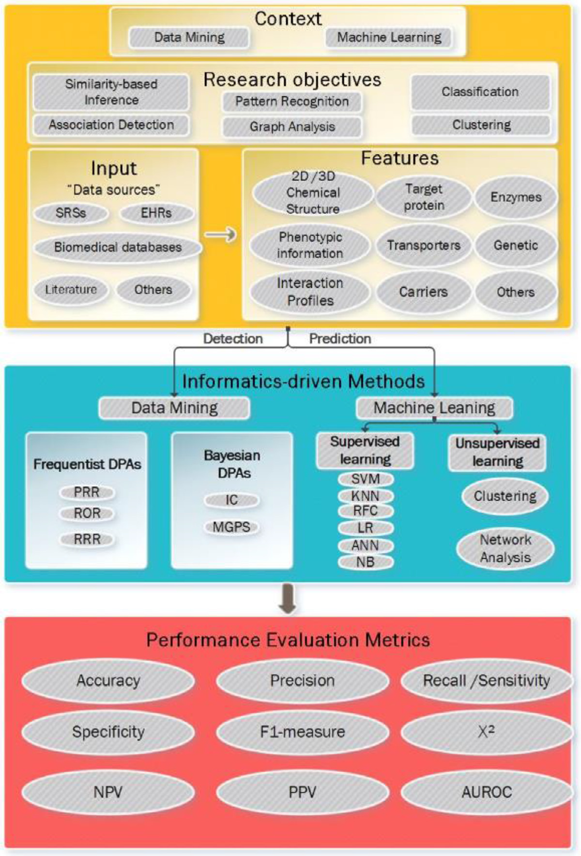

*ArtificialIntelligenceintheLifeSciences1(2021)100005*

**Fig.8.Amulti-layeredinformatics-drivenframeworkfordiscov-eringdrug-druginteractionssafetysignals.**SRS:SpontaneousRe-portingSystem;EHR:ElectronicHealthRecords;PRR:Proportional ReportingRatio;ROR:RelativeOddsRatio;RRR:RelativeReport-ingRatio;IC:InformationComponent;MGPS:Multi-GammaPoison Shrinker;SVM:SupportVectorMachine;KNN:K-nearestneighbor; RFC:RandomForestClassifier;LR:Logisticregression;ANN:Artifi-cialNeuralNetwork;NB:NaïveBayes;***𝑿***2:Chi-Square;NPV:Neg-ativePredictiveValue;PPV:PositivePredictiveValue;AUROC:Area undertheROCCurve.

**Table1**   
**SummaryofthePerformanceMetricsofMachineLearningandDataMiningmethodsadoptedinthestudiesdescribed in**sections4**and**6**,respectively.**AUCROC:AreaundertheReceiverOperatorCharacteristiccurve;DDI:drug-druginteraction; SRS:spontaneousreportingsystem;ARM:Associationrulemining;SVM:Supportvectormachine;IPF:Interactionprofile fingerprint;PPIN:Protein-proteininteractionnetwork.

|  |  |  |  |  |  |
| --- | --- | --- | --- | --- | --- |
|  | Method(Measurements) |  |  |  |  |
| ResearchObjective | BestSensitivity | BestPrecision | BestSpecificity | BestAccuracy | BestAUROC |

**DataminingmethodsforDDISignaldetectionimplementedtoSRSdata**

|  |  |  |
| --- | --- | --- |
| Associationpattern recognition(ARM) | HybridApriori(0.81) [72] | HybridApriori(0.85)  [72] |

**MachinelearningmethodsforDDISignaldetectionimplementedintobiomedicalknowledgedatabases**

|  |  |  |  |
| --- | --- | --- | --- |
| Classification  Similarity-based  modeling | MolecularStructure  Fingerprint(0.96)  [112]  PPIN(0.96)  [106] | PPIN(0.81) [109] | SVM(0.93)[117] IPF(0.96)  [113] |
| Networkanalysis |

11

|  |  |  |
| --- | --- | --- |
| *H.Ibrahim,A.Abdo,A.M.ElKerdawyetal.* | 12 | *ArtificialIntelligenceintheLifeSciences1(2021)100005* |
| experimental/clinicalinvestigationsmaybeneededtoprovidefurther evidencesforconfirmingaDDIsignal.Severalfactorshaveimpacton detectingDDIsignalswhereimportantonesmaybemissedorspuri-ousassociationsaremorelikelytobeproduced.Theseinfluencescan besummarizedin:minimaldemographicdata,duplicatedreports,no informationregardingpatientexposure,underreportingthatmayarti-ficiallyincreaseexpectedriskestimatesofthedrugs,verbatimmedical terms,unstandardizeddrugnames,etc.Accordingly,optimizingcurrent dataminingtechniqueswithchosenthresholdsaimingatovercoming rawdatachallengesandcapturingDDIsignalswithhighersensitivity andprecisioniscrucial.Also,researchershaveshownARManditsex-tendedalgorithmsasgoodchoicesforhandlingthesparseofpostmar-ketingPVdatawithinSRSswherestrongassociationpatternscouldbe generatedtoeasilyrecognizehigherorderofDrug-AEassociations.On theotherside,adoptingEHRsasacomplementarysourceforroutine PVpracticesgenerallyandDDIsignaldetectionspecificallyischalleng-ing.Thismaybeattributedtotheontologyproblems,heterogeneityof datafromvarioussourcesandpatients’informationaremainlybeing intextualformats,besidesconfoundingbyco-medications,riskfactors and/orcomorbidities.Hence,developingNLPapproachesandtobein-tegratedwithregressionmethodscanbeanoptiontohandleontology problemsalongwithmanagingconfounders.AnotheravenueofNLPcan beadoptedinregularPVdatainpurposesofreducingthelargespace ofdrug-drug-eventassociationsinherentlypresentinSRSsandallowing furtherprocessinginthecontextofDDIsignaldetection[134].  WhereasfromMLperspective,PPINframeworkprovidesabetter overallperformanceconcerningbothaccuracyandspecificitycompared toothermethods.While,SVMappearstohavethebestoverallDDIpre-dictiveperformanceintermsofAUROCcomparedtoothersupervised MLinpredictingDDIsignals[135–140].However,SVMhasinherited limitationsrepresentedinthetimelapseofmodelrunningandtheblack boxnaturelimitingtheinterpretationofthepredictionoutcomes.Inre-centyears,thedawnofadoptingsupervisedMLinPVsignaldetection hasresultedfromtheevolutionofmultipleusefulbiomedicalknowl-edgeresourcesasgoldstandardsoflabeledDDIs(e.g.DrugBank[141], KEGG,Micromedex),besidesusingtheseresourcestoassessthepredic-tiveperformanceofsupervisedMLavenues.  TheuseofsupervisedMLhasitslimitssuchasclassimbalance,sparse features,lowoverlappingandconsistencybetweendifferentDDIsre-sources[142].Therefore,advancementsinincorporatingunsupervised MLapproachesinDDIsdiscoverystudies,improvementsofDDIcor-poraannotation,andestablishingstandardizedguidelinesforestablish-ingDDIgoldreferencedatasetsareprobablyessentialstepstodevelop morerealisticMLframeworksduringdrug-development,aswellas,pre-marketingphases.Otherdirectionsofdevelopmentstobeimplemented intoroutinePVpracticesarerepresentedinhowMLmaycontribute inboostingDDIsignaldetectionfromSRSdataand/orpredictingtheir types/changeinseverity,combiningmorethanonedatasources(e.g. EHRs,patientsupportprograms,prospectivesurveys,randomizedcon-trolledtrials,etc.)ratherthanrestrictingtoSRSdata,assessingMLal-gorithmicperformancebyconstructingreliabletestsets,inadditionto advancingframeworksforincreasingtransparencyorexplainabilityof MLoutputs.  Accordingtotheabovementionedillustrationsandbeyondthestruc-turedPVdatasources,theexponentialincreaseofthescientificliter-aturecomplicatestheexplorationofsuchbiomedicalcorpora[143]. Biomedicalcorporaenablesconstructinglearningdatasetsofmedically relatedtermsthatembedpriorknowledgeandaidinthepragmaticuse ofcertainwordswithinspecificcontexts[120].Informatics-basedmeth-ods,inparticulartextminingandMLframeworkshavegreatapplicabil-ityinthisregardtoaidinextracting,analyzingandclassifyingbiological informationdesignatedinscientificpublications.Duringthepastyears, biomedicalcorporahavepresentedavaluablePVdatasourceforthe detectionandanalysisofDDIsignals.Theunstructurednatureofthis typeofdatasourcesischallenging.NaturalLanguageProcessing(NLP) approachesarecrucialinthiscontexttoannotate,standardizeandmap | relevantmedicalterminologiesandgenericdrugnamesiscrucialfor implementingreliablecomputationalmodels. |
| **8.Concludingremarks** |
| Theavailabilityoffreelyavailablesafetydatasourcesalongwith theadoptionofnovelDMand/orMLmethodshasadvancedthePV domain.Inthisreview,weparticularlyfocusondevelopmentsinin-formaticstechniquesinthecontextofDDIsignals.Wehaveshowna portfolioofPVresources,DMandMLapproachestechniquesproposed todiscoveradverseDDIsignals.Eachmethodmayre-stimulateinterest toevolveDDIsurveillancepracticesbyofferingdifferentprospects.To thebestweknow,theunderlyingpaperisthefirstreviewcombining machinelearninganddataminingmethodstodisclosepotentialsignals ofDDIsindrugsafetysurveillance.PossiblecausalDDIsassociationsare experimentedduringdrugdevelopmentcycle,thenmonitoredviapost-marketingPVsystemsafterbeinginmarket.Developingbetterpredic-tivemethods,toflagpotentialDDIsignals,becomesofgreatimportance toindustryandregulatorybodies[144,145].  TheblackboxnatureofMLmethodsisoneoftheirmajorlimita-tionsleadingtodifficultyininterpretingofwhatfeaturesareimpor-tantand/orinterpretingthemodelresults.However,generally,adopting informatics-drivenmethodstobeimplementedinregulardrugdevelop-mentprocesswillbevaluable.Sincethiswillenablegreaterlinkage betweenbasicexperimentalplatformsandcontrolledclinicalsettings earlyduringdrugdevelopmentphases,thenempoweringtheanalysisof importantsafetyconcernsforinvestigationaldrugsatearlierstageslead-ingtomoreefficienttriagefornoveldrugcandidatesforfurtherstepsin thedevelopmentprocess[146].Boostedpredictiveapproachescanbe achievedbyintegratingstructuralandbiologicalknowledgewithen-richedsafetydatasets[147]**.**Previousstudieshaveshownbenefitsfrom linkingdrugs’phenotypic,therapeutic,structural,andgenomicinforma-tioninrevealingDDIpatternsinbothdrugdiscoveryandpostmarketing PVprocesses[148–150].  Innovativeparadigmshavearisenfromexploitingvariousdata sourcescomparedtoconventionalPVpractices,permittingfortheac-tivemonitoringofDDIdrugprofiles.Asspontaneoussystemsarecon-sideredthebiggestassemblyofrealworlddatafordistinguishingDDIs [151–154].Thediscoveryofhigher-orderdrug–eventcombinationsis morechallengingthanidentifyingsignalsofsingledrug–eventpairsdue tothelimitationofunder-reportingratesinlargeSRSs.Althoughthe DDIdetectionresearchshiftedawayfromSRSsutilizationintoother datasourcesintherecentyears,thiscouldn’treplacethemainroleof SRSsinregularPV.Accordingly,moreeffortsarerequiredinpurposes ofevolvingmethodsforroutineDDIsdiscoveryacrossdifferentsafety datasources.  Also,themainchallengeinDDIsignaldetectionstudiesisthelack ofwell-establishedguidancesforassessinginformatics-drivenmethods performance.Principally,thisisduetothelackofreferencestandardfor interactionsafetyprofilesofthewholemarketeddrugproducts[155]. Hence,researchersshouldconductmorestudieswithpurposesforac-quiringbettercomprehensiontothelandscapesofmultivariateassoci-ationmeasuresalongwithestimatingcorrespondingpredictiveperfor-mance.Furthermore,developingapproachestargetingtheestimationof optimalDDIsignaldetectionthresholdsthatachievebalancedtrade-off betweensensitivityandspecificitywithdecreasingfalsesignalscanbe avaluableperspective.  Inconclusion,informatics-drivenapproachesdon’tprovecausality association,butinsteadtheycanbevaluablecomplementarytoolto flaghypothesesofDDIcombinationsandsupportsignalassessment. Comprehensiveclinicaljudgmentwillalwaysendurefundamentalfor establishingcausalrelationshipsbetweendrugsandsafetyconcerns. |
| **DeclarationofCompetingInterest** |
| Theauthorsdeclarethattheyhavenoknowncompetingfinancial interestsorpersonalrelationshipsthatcouldhaveappearedtoinfluence theworkreportedinthisreviewpaper. |

*H.Ibrahim,A.Abdo,A.M.ElKerdawyetal.*  *ArtificialIntelligenceintheLifeSciences1(2021)100005*

**References**  [biomedicaltexts.In:ProceedingsoftheACMfourthinternationalworkshopon](http://refhub.elsevier.com/S2667-3185(21)00005-2/sbref0031)  [dataandtextmininginbiomedicalinformatics(DTMBIO’10);2010.p.49–56.](http://refhub.elsevier.com/S2667-3185(21)00005-2/sbref0031)

[[10]BuiPH,QuesadaA,HandforthA,HankinsonO.TheMibefradilDerivative](http://refhub.elsevier.com/S2667-3185(21)00005-2/sbref0009)

[[11]MeinertzT.Mibefradil-adrugwhichmayenhancethepropensityforthedevel-](http://refhub.elsevier.com/S2667-3185(21)00005-2/sbref0010)  
[[12]USFoodandDrugAdministration[online].AvailablefromURL:http://www.](http://refhub.elsevier.com/S2667-3185(21)00005-2/sbref0011)   
[[13]RobertsonS,PenzakS,ArthurJA,DarrellRA,CharlesED,etal..DrugInteractions.](http://www.fda.gov/Drugs/GuidanceComplianceRegulatory)   
[[14]PatsalosPN,PeruccaE.Clinicallyimportantdruginteractionsinepilepsy:gen-](http://refhub.elsevier.com/S2667-3185(21)00005-2/sbref0013)

[[15]OpieLH.Adversecardiovasculardruginteractions.CurrentProblemsinCardiology](http://refhub.elsevier.com/S2667-3185(21)00005-2/sbref0014)   
[[16]BoobisA,Gundert-RemyU,KremersP,MacherasP,PelkonenO.Insilicoprediction](http://refhub.elsevier.com/S2667-3185(21)00005-2/sbref0015)

[[17]FerdousiR,SafdariR,OmidiY.Computationalpredictionofdrug-druginterac-](http://refhub.elsevier.com/S2667-3185(21)00005-2/sbref0016)

[[18]AlvarezY,HidalgoA,MaignenF,SlatteryJ.Validationofstatisticalsignaldetection](http://refhub.elsevier.com/S2667-3185(21)00005-2/sbref0017)

[[19]LindquistM.VigiBase,theWHOglobalICSRdatabasesystem:basicfacts.DrugInf](http://refhub.elsevier.com/S2667-3185(21)00005-2/sbref0018)   
[[20]The(FAERS):QuarterlyDataFiles.Available:http://www.fda.gov/Drugs/](http://refhub.elsevier.com/S2667-3185(21)00005-2/sbref0019)

[[21]ZhanC,RougheadE,LiuL,PrattN,LiJ.Detectinghigh-qualitysignalsofad-](http://refhub.elsevier.com/S2667-3185(21)00005-2/sbref0021)

[[22]EudraVigilance[online].Available:http://www.ema.europa.eu/ema/index.jsp?](http://refhub.elsevier.com/S2667-3185(21)00005-2/sbref0021)

[23][Vaccineadverseeventrepor](https://vaers.hhs.gov/data.html)tingsystems(VAERS).AvailablefromURL:   
[[24]](http://refhub.elsevier.com/S2667-3185(21)00005-2/sbref0024)[IvanovS,LaguninA,FilimonovD](https://vaers.hhs.gov/data.html)[,PoroikovV.Assessmentofthecardiovascularad-](http://refhub.elsevier.com/S2667-3185(21)00005-2/sbref0024)

[[25]International](http://refhub.elsevier.com/S2667-3185(21)00005-2/sbref0024)

[[26]WysowskiDK,SwartzL.Adversedrugeventsurveillanceanddrugwithdrawals](http://refhub.elsevier.com/S2667-3185(21)00005-2/sbref0026)

[[27]AronsonAR.Effectiv](http://refhub.elsevier.com/S2667-3185(21)00005-2/sbref0026)e[mappingofbiomedicaltexttotheUMLSmetathesaurus:The](http://refhub.elsevier.com/S2667-3185(21)00005-2/sbref0026)   
[[28]FriedmanC,ShaginaL,LussierY,HripcsakG.Automatedencodingofclini-](http://refhub.elsevier.com/S2667-3185(21)00005-2/sbref0027)

[[29]Rindflesc](http://refhub.elsevier.com/S2667-3185(21)00005-2/sbref0028)h[TC,FiszmanM.Theinteractionofdomainknowledgeandlinguistic](http://refhub.elsevier.com/S2667-3185(21)00005-2/sbref0028)

[[30]WangX,HripcsakG,MarkatouM,FriedmanC.Drugsafetysurveillanceusingde-i-](http://refhub.elsevier.com/S2667-3185(21)00005-2/sbref0029)

[[31]Segura-BedmarI,MartínezP,DePablo-SánchezC.Combiningsyntacticinforma-](http://refhub.elsevier.com/S2667-3185(21)00005-2/sbref0030)  
[1]EdwardsIR,AronsonJK.Adversedrugreactions:definitions,diagnosis,andman-  
[2]HartfordCG,PetchelKS,MickailH,Perez-GutthannS,McHaleM,GranaJM,Mar-

[[3]Sanson-FisherRW,BonevskiB,GreenLW,D’EsteC.Limitationsoftherandomized](http://refhub.elsevier.com/S2667-3185(21)00005-2/sbref0002)

[[4]AmeryWK.Whythereisaneedforpharmacovigilance.PharmacoepidemiolDrug](http://refhub.elsevier.com/S2667-3185(21)00005-2/sbref0004)   
[[5]PirmohamedD,OrrneML,etal.DrugInteractionsofClinicalImportance.In:](http://refhub.elsevier.com/S2667-3185(21)00005-2/sbref0004)

[[6]GombaVK,EnsleinK,BlakeBW.Assessmentofdevelopmentaltoxicitypotential](http://refhub.elsevier.com/S2667-3185(21)00005-2/sbref0005)

[[7]VanderHeijdenPG,vanPuijenbroekEP,vanBuurenS,vanderHofstedeJW.On](http://refhub.elsevier.com/S2667-3185(21)00005-2/sbref0006)

[[8]OlveyEL,ClauscheeS,MaloneDC.Comparisonofcriticaldrug-druginteraction](http://refhub.elsevier.com/S2667-3185(21)00005-2/sbref0007)

[[9]NorénG,SundbergR,BateA.Astatisticalmethodologyfordrug-druginteraction](http://refhub.elsevier.com/S2667-3185(21)00005-2/sbref0008)   
 agement.Lancet2000;356:1255–9.

[quezP.Pharmacovigilanceduringthepre-approvalphases:anevolvingpharma-](http://refhub.elsevier.com/S2667-3185(21)00005-2/sbref0002)  
[ceuticalindustrymodelinresponsetoICHE2E,CIOMSVI,FDAandEMEA/CHMP](http://refhub.elsevier.com/S2667-3185(21)00005-2/sbref0002)   
[riskmanagementguidelines.DrugSaf2006;29(8):657–73.](http://refhub.elsevier.com/S2667-3185(21)00005-2/sbref0002)

[controlledtrialinevaluatingpopulation-basedhealthinterventions.AmJPrevMed](http://refhub.elsevier.com/S2667-3185(21)00005-2/sbref0003)   
[2007;33(2):155–61.](http://refhub.elsevier.com/S2667-3185(21)00005-2/sbref0004)

[Saf1999;8(1):61–4.](http://refhub.elsevier.com/S2667-3185(21)00005-2/sbref0004)

[DaviesD,etal.,editors.Davies’sTextbookofadverseDrugReactions.London:](http://refhub.elsevier.com/S2667-3185(21)00005-2/sbref0005)   
[Chapman&HallMedical;1998.p.888–912.London.](http://refhub.elsevier.com/S2667-3185(21)00005-2/sbref0005)

[ofchemicalsbyquantitativestructure–toxicityrelationshipmodels.Chemosphere](http://refhub.elsevier.com/S2667-3185(21)00005-2/sbref0006)   
[1995;31(1):2499–510.](http://refhub.elsevier.com/S2667-3185(21)00005-2/sbref0006)

[theassessmentofadversedrugreactionsfromspontaneousreportingsystems:the](http://refhub.elsevier.com/S2667-3185(21)00005-2/sbref0007)   
[influenceofunderreportingonoddsratios.StatMed2002;21(14):2027e44.](http://refhub.elsevier.com/S2667-3185(21)00005-2/sbref0007)

[listings:theDepartmentofVeteransAffairsmedicalsystemandstandardreference](http://refhub.elsevier.com/S2667-3185(21)00005-2/sbref0008)   
[compendia.ClinPharmacolTher2010;87(1):48e51.](http://refhub.elsevier.com/S2667-3185(21)00005-2/sbref0008)

[surveillance.StatMed2008;27:3057–70.](http://refhub.elsevier.com/S2667-3185(21)00005-2/sbref0009)

[NNC55-0396,aSpeci](http://refhub.elsevier.com/S2667-3185(21)00005-2/sbref0010)fic[T-TypeCalciumChannelAntagonist,ExhibitsLessCYP3A4](http://refhub.elsevier.com/S2667-3185(21)00005-2/sbref0010)   
[InhibitionthanMibefradilDrugMetab.Dispos2008;36(7):1291–9.](http://refhub.elsevier.com/S2667-3185(21)00005-2/sbref0010)

[opmentofabnormalQTprolongation.EurHeartJ2001;3:K89–92Suppl.](http://refhub.elsevier.com/S2667-3185(21)00005-2/sbref0011)

[fda.gov/Drugs/GuidanceComplianceRegulatory.Acessed20December2020.](http://www.fda.gov/Drugs/GuidanceComplianceRegulatory)

[PrinciplesofClinicalPharmacology.Burlington:AcademicPress;2007.p.229–47.](http://refhub.elsevier.com/S2667-3185(21)00005-2/sbref0013)

[eralfeaturesandinteractionsbetweenantiepilepticdrugs.TheLancetNeurology](http://refhub.elsevier.com/S2667-3185(21)00005-2/sbref0014)   
[2003;2:347–56.](http://refhub.elsevier.com/S2667-3185(21)00005-2/sbref0014)

[2000;25:628–32.](http://refhub.elsevier.com/S2667-3185(21)00005-2/sbref0015)

[ofADMEandpharmacokinetics:ReportofanexpertmeetingorganizedbyCOST](http://refhub.elsevier.com/S2667-3185(21)00005-2/sbref0016)   
[B15.EurJPharmSci2002;17:183–93.](http://refhub.elsevier.com/S2667-3185(21)00005-2/sbref0016)

[tionsbasedondrugsfunctionalsimilarities.JournalofBiomedicalInformatics](http://refhub.elsevier.com/S2667-3185(21)00005-2/sbref0017)   
[2017;70:54–64.](http://refhub.elsevier.com/S2667-3185(21)00005-2/sbref0017)

[proceduresinEudraVigilancepostauthorisationdata:aretrospectiveevaluationof](http://refhub.elsevier.com/S2667-3185(21)00005-2/sbref0018)   
[thepotentialforearliersignalling.DrugSaf2010;33:475–87.](http://refhub.elsevier.com/S2667-3185(21)00005-2/sbref0018)

[J2008;42(5):409–19.](http://refhub.elsevier.com/S2667-3185(21)00005-2/sbref0019)

GuidanceComplianceRegulatoryInformation/Surveillance/AdverseDrugEffects/ucm082193.htm[.](http://refhub.elsevier.com/S2667-3185(21)00005-2/sbref0050) [Acessed04November2020.](http://refhub.elsevier.com/S2667-3185(21)00005-2/sbref0021)

[versedrug-druginteractionsfromspontaneousreportingdata.JBiomedInform](http://refhub.elsevier.com/S2667-3185(21)00005-2/sbref0021)   
[2020;112:103603.](http://refhub.elsevier.com/S2667-3185(21)00005-2/sbref0021)

[Acessed curl=pages/regulation/document_listing/document_listing_000239.jsp.](http://www.ema.europa.eu/ema/index.jsp?curl=pages/regulation/document_listing/document_listing_000239.jsp)

[11December2020.](http://www.ema.europa.eu/ema/index.jsp?curl=pages/regulation/document_listing/document_listing_000239.jsp)

<https://vaers.hhs.gov/data.html>[.Acessed16December2020.](http://refhub.elsevier.com/S2667-3185(21)00005-2/sbref0024)

[verseeffectsofdrug-druginteractionsthroughacombinedanalysisofspontaneous](http://refhub.elsevier.com/S2667-3185(21)00005-2/sbref0024)   
[reportsandpredicteddrug-targetinteractions.PLoSComputBiol2019;15(7).](http://refhub.elsevier.com/S2667-3185(21)00005-2/sbref0024)

[http://www.ich.org/products/guidelines/efficacy/article/efficacyguidelines.](http://www.ich.org/products/guidelines/efficacy/article/efficacyguidelines.html)html[.](http://www.ich.org/products/guidelines/efficacy/article/efficacyguidelines.html)

[Acessed24October2020.](http://www.ich.org/products/guidelines/efficacy/article/efficacyguidelines.html)

[intheUnitedStates,1969-2002:theimportanceofreportingsuspectedreactions.](http://refhub.elsevier.com/S2667-3185(21)00005-2/sbref0026)

[Arch.Intern.Med.2005;165(12):1363–9.](http://refhub.elsevier.com/S2667-3185(21)00005-2/sbref0026)

[MetaMapprogram.In:ProcAMIASymp.;2001.p.17–21.](http://refhub.elsevier.com/S2667-3185(21)00005-2/sbref0027)

[caldocumentsbasedonnaturallanguageprocessing.JAmMedInformAssoc](http://refhub.elsevier.com/S2667-3185(21)00005-2/sbref0028)   
[2004;11(5):392–402.](http://refhub.elsevier.com/S2667-3185(21)00005-2/sbref0028)

[structureinnaturallanguageprocessing:Interpretinghypernymicpropositionsin](http://refhub.elsevier.com/S2667-3185(21)00005-2/sbref0029)   
[biomedicaltext.JBiomedInform2003;36(6):462–77.](http://refhub.elsevier.com/S2667-3185(21)00005-2/sbref0029)

[dentifi](http://refhub.elsevier.com/S2667-3185(21)00005-2/sbref0030)ed[EMRandclaimsdata:issuesandchallenges.JAmMedInformAssoc](http://refhub.elsevier.com/S2667-3185(21)00005-2/sbref0030)   
[2009;16(3):328–37.](http://refhub.elsevier.com/S2667-3185(21)00005-2/sbref0030)

[tionanddomain-specifi](http://refhub.elsevier.com/S2667-3185(21)00005-2/sbref0031)c[lexicalpatternstoextractdrug–druginteractionsfrom](http://refhub.elsevier.com/S2667-3185(21)00005-2/sbref0031)   
 ICH Conference on Harmonisation,

[E2B](http://refhub.elsevier.com/S2667-3185(21)00005-2/sbref0024)   
[32]GurulingappaH,Mateen-RajputA,ToldoL.Extractionofpotentialadversedrug [33]DandalaB,JoopudiV,TsouCH,LiangJJ,SuryanarayananP.ExtractionofInfor-

[34][Bouzillé G,MorivalC,WesterlynckR,etal.AnAutomatedDetectionSys-](http://refhub.elsevier.com/S2667-3185(21)00005-2/sbref0033)

[35][Tar](http://refhub.elsevier.com/S2667-3185(21)00005-2/sbref0035)[iL,AnwarS,LiangS,](https://doi.org/10.3233/shti190180)[CaiJ,BaralC.Discoveringdrug–druginteractions:atex-](http://refhub.elsevier.com/S2667-3185(21)00005-2/sbref0035)

[36][Kostoff](http://refhub.elsevier.com/S2667-3185(21)00005-2/sbref0035) R[.Theextractionofusefulinformationfromthebiomedicalliterature.ACA-](http://refhub.elsevier.com/S2667-3185(21)00005-2/sbref0035)  
[37][ZhangT,LengJ,LiuY.Deeplearningfordrug-druginteractionextractionfrom](http://refhub.elsevier.com/S2667-3185(21)00005-2/sbref0036)

[38]Dru[gBankwebsite.Avail](https://doi.org/10.1093/bib/bbz087)ableatURL:[http://www.drugbank.ca/.](http://www.drugbank.ca/)Acessed14Au-  
[39]PharmGKBdatabase.AvailablefromURL:[https://www.pharmgkb.org/index.jsp.](https://www.pharmgkb.org/index.jsp)   
[40][KuhnM,vonMeringC,CampillosM,JensenLJ,BorkP.STITCH:interaction](http://refhub.elsevier.com/S2667-3185(21)00005-2/sbref0040)

[41][VanderwallDE,etal.Molecularclinicalsafetyintelligence:asystemforbridging](http://refhub.elsevier.com/S2667-3185(21)00005-2/sbref0041)

[42][YangCC,YangH.Miningheterogeneousnetworkswithtopologicalfeaturescon-](http://refhub.elsevier.com/S2667-3185(21)00005-2/sbref0041)

[43][TingSL,ShumCC,](http://refhub.elsevier.com/S2667-3185(21)00005-2/sbref0043)[KwokSK,TsangAHC,LeeWB.](https://doi.org/10.1016/j.artmed.2018.07.002)[DataMininginBiomedicine:](http://refhub.elsevier.com/S2667-3185(21)00005-2/sbref0043)

[44][NoguchiY,AoyamaK,KuboS,TachiT,TeramachiH.ImprovedDetectionCrite-](http://refhub.elsevier.com/S2667-3185(21)00005-2/sbref0043)

[45][NoguchiY,TachiT,TeramachiH.ComparisonofSignalDetectionAl-](http://refhub.elsevier.com/S2667-3185(21)00005-2/sbref0044)

[46][Hau](http://refhub.elsevier.com/S2667-3185(21)00005-2/sbref0046)[benM,ZhouX.Quantitative](https://doi.org/10.1007/s11095-020-02801-3)[MethodsinPharmacovigilance:focusonsignal](http://refhub.elsevier.com/S2667-3185(21)00005-2/sbref0046)   
[47][EvansSJ,WallerPC,DavisS.Useofproportionalreportingratios(PRRs)forsignal](http://refhub.elsevier.com/S2667-3185(21)00005-2/sbref0046)

[48][EvansSJ.Pharmacovigilance:ascienceorfieldin](http://refhub.elsevier.com/S2667-3185(21)00005-2/sbref0047)g[emergencies?StatMed](http://refhub.elsevier.com/S2667-3185(21)00005-2/sbref0047)   
[49][CheeBW,BerlinR,SchatzB.Description:PredictingAdverseDrugEventsfrom](http://refhub.elsevier.com/S2667-3185(21)00005-2/sbref0048)   
[[50]](http://www.fda.gov/Drugs/GuidanceComplianceRegulatoryInformation/Surveillance/AdverseDrugEffects/ucm082193.htm)[BateA,LindquistM,EdwardsIR,OlssonS,OrreR,LansnerA,De-FreitasRM.A](http://refhub.elsevier.com/S2667-3185(21)00005-2/sbref0049)

[51][BateA,LindquistM,EdwardsIR,OrreR.Adataminingapproachforsignaldetec-](http://refhub.elsevier.com/S2667-3185(21)00005-2/sbref0050)  
[52][DuMouchelW.Bayesiandatamininginlargefrequencytables,withanapplication](http://refhub.elsevier.com/S2667-3185(21)00005-2/sbref0051)   
[53][AgrawalR,ImielinskiT,SwamiA.Miningassociationrulesbetweensetsofitems](http://refhub.elsevier.com/S2667-3185(21)00005-2/sbref0052)

[54][IskanderJ,PoolV,ZhouW,English-BullardR.DataminingintheUSusingthe](http://refhub.elsevier.com/S2667-3185(21)00005-2/sbref0053)   
[55][CarrinoJA,Ohno-MachadoL.Developmentofradiologypredictionmodelsusing](http://refhub.elsevier.com/S2667-3185(21)00005-2/sbref0054)   
[56][SarawagiS,ThomasS,AgrawalR.Integratingassociationruleminingwithre-](http://refhub.elsevier.com/S2667-3185(21)00005-2/sbref0055)

[57][IyerSV,LependuP,HarpazR,Bauer-MehrenA,ShahNH.LearningSignalsof](http://refhub.elsevier.com/S2667-3185(21)00005-2/sbref0057)

[58][MantelN,HaenszelW.Statisticalaspectsoftheanalysisofdatafromretrospective](http://refhub.elsevier.com/S2667-3185(21)00005-2/sbref0057)   
[59][NorenGN,BateA,OrreR,EdwardsIR.Extendingthemethodsusedtoscreenthe](http://refhub.elsevier.com/S2667-3185(21)00005-2/sbref0058)

[60][HopstadiusJ,NorénGN,BateA,EdwardsIR.Impactofstratificatio](http://refhub.elsevier.com/S2667-3185(21)00005-2/sbref0059)n[onadverse](http://refhub.elsevier.com/S2667-3185(21)00005-2/sbref0059)   
[61][NicholasP.Jewell.StatisticsforEpidemiology.Textsforstatisticalsciences.Chap-](http://refhub.elsevier.com/S2667-3185(21)00005-2/sbref0060)  
[62][VanPuijenbroekEP,EgbertsAC,HeerdinkER,LeufkensHG.Detectingdrug-drug](http://refhub.elsevier.com/S2667-3185(21)00005-2/sbref0061)   
eventsfrommedicalcasereports.JBiomedSemantics2012;20(1):153.

[mationRelatedtoDru](http://refhub.elsevier.com/S2667-3185(21)00005-2/sbref0033)g[SafetySurveillanc](http://refhub.elsevier.com/S2667-3185(21)00005-2/sbref0033)e[FromElectronicHealthRecordNotes:](http://refhub.elsevier.com/S2667-3185(21)00005-2/sbref0033)   
[JointModelingofEntitiesandRelationsUsingKnowledge-AwareNeuralAttentive](http://refhub.elsevier.com/S2667-3185(21)00005-2/sbref0033)   
[Models.JMIRMedInform2020;10(7):e184178.](http://refhub.elsevier.com/S2667-3185(21)00005-2/sbref0033)

[t-miningandreasoningapproachbasedonpropertiesofdrugmetabolism.Bioin-](http://refhub.elsevier.com/S2667-3185(21)00005-2/sbref0035)

doi[:10.1093/bib/bbz087.](https://doi.org/10.1093/bib/bbz087)   
gust2020.

[Acessed09July2020.](http://refhub.elsevier.com/S2667-3185(21)00005-2/sbref0040)

[sue):D684–8.](http://refhub.elsevier.com/S2667-3185(21)00005-2/sbref0041)

[ence.DrugDiscovToday2011;16(15-16):646–53.](http://refhub.elsevier.com/S2667-3185(21)00005-2/sbref0041)

structedfrompatien[t-contributedcontentforpharm](https://doi.org/10.1016/j.artmed.2018.07.002)acovigilance.ArtifIntellMed   
[2018;90:42–52.do](http://refhub.elsevier.com/S2667-3185(21)00005-2/sbref0043)i[:10.1016/j.artmed.2018.07.002.](https://doi.org/10.1016/j.artmed.2018.07.002)

[CurrentApplicationsandFurtherDirectionsforResearch.JSoftwareEngineering](http://refhub.elsevier.com/S2667-3185(21)00005-2/sbref0043)   
[&Applications2009;2:150–9.](http://refhub.elsevier.com/S2667-3185(21)00005-2/sbref0043)

[Ratio.Pharmaceuticals2021;14(4).](http://refhub.elsevier.com/S2667-3185(21)00005-2/sbref0044)

gorithmsBasedonFrequencyStatisticalModelforDrug-DrugInterac-  
tion[UsingSpontaneousReport](https://doi.org/10.1007/s11095-020-02801-3)ingSystems.PharmRes2020;30(5):8637.

[PersonalHealthMessages.AMIAAnnuSympProc2011:217–26.](http://refhub.elsevier.com/S2667-3185(21)00005-2/sbref0049)

[Bayesianneuralnetworkmethodforadvers](http://refhub.elsevier.com/S2667-3185(21)00005-2/sbref0050)e[drugreactionsignalgeneration.Eur](http://refhub.elsevier.com/S2667-3185(21)00005-2/sbref0050)   
[JClinPharmacol1998;54(4):315–21.](http://refhub.elsevier.com/S2667-3185(21)00005-2/sbref0050)

[tionandanalysis.DrugSaf2002;25(6):393–7.](http://refhub.elsevier.com/S2667-3185(21)00005-2/sbref0051)

[theFDASpontaneousReportingSystem.Am.Stat.1999;53(3):177–90.](http://refhub.elsevier.com/S2667-3185(21)00005-2/sbref0052)

[inlargedatabases.In:ProceedingsoftheACMSIGMODinternationalconference](http://refhub.elsevier.com/S2667-3185(21)00005-2/sbref0053)   
[onmanagementofdata;1993.p.207–16.](http://refhub.elsevier.com/S2667-3185(21)00005-2/sbref0053)

[vaccineadverseeventreportingsystem.DrugSaf2006;29(5):375–84.](http://refhub.elsevier.com/S2667-3185(21)00005-2/sbref0054)

[featureanalysis.AcadRadiol2005;12(4):415–21.](http://refhub.elsevier.com/S2667-3185(21)00005-2/sbref0055)

[lationaldatabasesystems:alternativesandimplications.DataMiningKnowledge](http://refhub.elsevier.com/S2667-3185(21)00005-2/sbref0056)   
[Discov2000;4(2):89–125.](http://refhub.elsevier.com/S2667-3185(21)00005-2/sbref0057)

[AdverseDrug-DrugInteractionsfromtheUnstructuredTextofElectronicHealth](http://refhub.elsevier.com/S2667-3185(21)00005-2/sbref0057)   
[Records.AMIAJtSummitsTranslSciProc2013:216.](http://refhub.elsevier.com/S2667-3185(21)00005-2/sbref0057)

[studiesofdisease.JNatCancerInst1959;22(4):719–48.](http://refhub.elsevier.com/S2667-3185(21)00005-2/sbref0058)

[WHOdrugsafetydatabasetowardsanalysisofcomplexassociationsandimproved](http://refhub.elsevier.com/S2667-3185(21)00005-2/sbref0059)   
[accuracyforrareevents.StatMed2006;25(21):3740–57.](http://refhub.elsevier.com/S2667-3185(21)00005-2/sbref0059)

[drugreactionsurveillance.DrugSaf2008;31(11):1035–48.](http://refhub.elsevier.com/S2667-3185(21)00005-2/sbref0060)

[interactionsusingadatabaseforspontaneousadversedrugreactions:anexample](http://refhub.elsevier.com/S2667-3185(21)00005-2/sbref0062)   
[withdiureticsandnon-steroidalanti-inflammatorydrugs.EurJClinPharmacol](http://refhub.elsevier.com/S2667-3185(21)00005-2/sbref0062)   
[2000;56(9-10):733–8.](http://refhub.elsevier.com/S2667-3185(21)00005-2/sbref0062)

temofDrug-DrugInteractionsfromElectronicPatientRecordsUsingBig   
Dat[aAnalytics.Studies](https://doi.org/10.3233/shti190180)inHealthTechnologyandInformatics2019;264:45–9.   
[doi](http://refhub.elsevier.com/S2667-3185(21)00005-2/sbref0035)[:10.3233/shti190180.](https://doi.org/10.3233/shti190180)

[formatics2010;26(18):i547–53.](http://refhub.elsevier.com/S2667-3185(21)00005-2/sbref0035)

[DEMICMEDICINE2001;76(12):1265–70.](http://refhub.elsevier.com/S2667-3185(21)00005-2/sbref0036)

the[literature:areview.B](https://doi.org/10.1093/bib/bbz087)riefBioinform2020;25(5):1609–2721PMID:31686105.

[networksofchemicalsandproteins.NucleicAcidsRes2008;36(Databaseis-](http://refhub.elsevier.com/S2667-3185(21)00005-2/sbref0040)

[clinicallyfocusedsafetyknowledgetoearlystagedrugdiscovery-theGSKexperi-](http://refhub.elsevier.com/S2667-3185(21)00005-2/sbref0041)

[riaforDetectingDrug-DrugInteractionSignalsUsingtheProportionalReporting](http://refhub.elsevier.com/S2667-3185(21)00005-2/sbref0044)

[doi](http://refhub.elsevier.com/S2667-3185(21)00005-2/sbref0046)[:10.1007/s11095-020-02801-3.](https://doi.org/10.1007/s11095-020-02801-3)

[detection.DrugSaf2003;26(3):159–86.](http://refhub.elsevier.com/S2667-3185(21)00005-2/sbref0046)

[generationfromspontaneousadversedrugreactionreports.Pharmacoepidemiol](http://refhub.elsevier.com/S2667-3185(21)00005-2/sbref0047)   
[DrugSaf2001;10(6):483–6.](http://refhub.elsevier.com/S2667-3185(21)00005-2/sbref0047)

[2000;19(23):3199–209.](http://refhub.elsevier.com/S2667-3185(21)00005-2/sbref0048)

[manandHall;2004.Hardcoveredition.](http://refhub.elsevier.com/S2667-3185(21)00005-2/sbref0061)

13

*H.Ibrahim,A.Abdo,A.M.ElKerdawyetal.*

[[63]VanPuijenbroekEP,EgbertsAC,MeyboomRH,LeufkensHG.Signallingpossible drug–druginteractionsinaspontaneousreportingsystem:delayofwithdrawal bleedingduringconcomitantuseoforalcontraceptivesanditraconazole.BrJClin Pharmacol1999;47(6):689–93.](http://refhub.elsevier.com/S2667-3185(21)00005-2/sbref0063)

[[64]VanPuijenbroekEP,EgbertsAC,HeerdinkER,LeufkensHG.Detectingdrug–drug](http://refhub.elsevier.com/S2667-3185(21)00005-2/sbref0063) [interactionsusingadatabaseforspontaneousadversedrugreactions:anexample withdiureticsandnon-steroidalanti-inflammatorydrugs.EurJClinPharmacol 2000;56(9-10):733–8.](http://refhub.elsevier.com/S2667-3185(21)00005-2/sbref0064)

[[65]RawlinsMD.Spontaneousreportingofadversedrugreactions.II:Uses.BrJClin](http://refhub.elsevier.com/S2667-3185(21)00005-2/sbref0064)  [Pharmacol1988;26(1):7–11.](http://refhub.elsevier.com/S2667-3185(21)00005-2/sbref0065)

[[66]RouxE,ThiessardF,FourrierA,BégaudB.Tubert-BitterP.Evaluationofstatistical](http://refhub.elsevier.com/S2667-3185(21)00005-2/sbref0065) [associationmeasuresfortheautomaticsignalgenerationinpharmacovigilance. IEEETranINFTechnolBiomed2005;9(4):518–27.](http://refhub.elsevier.com/S2667-3185(21)00005-2/sbref0066)

[[67]VanPuijenbroekEP,BateA,LeufkensHG,LindquistM,OrreR,EgbertsAC.](http://refhub.elsevier.com/S2667-3185(21)00005-2/sbref0066)

[Acomparisonofmeasuresofdisproportionalityforsignaldetectioninsponta-neousreportingsystemsforadversedrugreactions.PharmacoepidemiolDrugSaf 2002;11(1):3–10.](http://refhub.elsevier.com/S2667-3185(21)00005-2/sbref0067)

[[68]ChoiCA,ChangMJ,ChoiHD,ChungWY,ShinWG.Applicationofadrug-inter-](http://refhub.elsevier.com/S2667-3185(21)00005-2/sbref0067)[actiondetectionmethodtotheKoreanNationalHealthInsuranceclaimsdatabase. RegulToxicolPharmacol;2013;67(2):294–8.](http://refhub.elsevier.com/S2667-3185(21)00005-2/sbref0068)

[[69]YangX,FramD.Usingdisproportionalityanalysisasatooltoexploredrug-drug](http://refhub.elsevier.com/S2667-3185(21)00005-2/sbref0068)  [interavtionsinAERSdatabase.PharmacoepidemiolDrugSafety2004;13:S247.](http://refhub.elsevier.com/S2667-3185(21)00005-2/sbref0069)

[[70]SchuemieMJ.Methodsfordrugsafetysignaldetectioninlongitudinalob-](http://refhub.elsevier.com/S2667-3185(21)00005-2/sbref0069)[servationaldatabases:LGPSandLEOPARD.PharmacoepidemiolDrugSaf 2011;20:292–9.](http://refhub.elsevier.com/S2667-3185(21)00005-2/sbref0070)

[[71]HarpazR,HaerianK,ChaseHS,FriedmanC.StatisticalMiningofPotentialDrug](http://refhub.elsevier.com/S2667-3185(21)00005-2/sbref0070) [Interactio](http://refhub.elsevier.com/S2667-3185(21)00005-2/sbref0071)n[AdverseEffect](http://refhub.elsevier.com/S2667-3185(21)00005-2/sbref0071)s[inFDA’sSpontaneousReportingSystem.ProcofAMIA AnnuSymp2010:281–5128.](http://refhub.elsevier.com/S2667-3185(21)00005-2/sbref0071)

[[72]IbrahimH,SaadA,AbdoA,SharafEA.Miningassociationpatternsofdrug-inter-](http://refhub.elsevier.com/S2667-3185(21)00005-2/sbref0071)[actionsusingpostmarketin](http://refhub.elsevier.com/S2667-3185(21)00005-2/sbref0072)g[FDA’sspontaneousreportingdata.JBiomedInform 2016;60:294–308.](http://refhub.elsevier.com/S2667-3185(21)00005-2/sbref0072)

[[73]VanPuijenbroekEP,EgbertsAC,HeerdinkER,LeufkensHG.Detectingdrug–drug](http://refhub.elsevier.com/S2667-3185(21)00005-2/sbref0072) [interactionsusingadatabaseforspontaneousadversedrugreactions:anexample withdiureticsandnon-steroidalanti-inflammatorydrugs.EurJClinPharmacol 2000;56(9-10):733–8.](http://refhub.elsevier.com/S2667-3185(21)00005-2/sbref0073)

[[74]ThakrarBT,GrundschoberSB,DoesseggerL.Detectingsignalsofdrug–druginter-](http://refhub.elsevier.com/S2667-3185(21)00005-2/sbref0073)[actionsinaspontaneousreportsdatabase.BrJClinPharmacol2007;64(4):489–95. [75]IyerSV,HarpazR,LePenduP,Bauer-MehrenA,ShahNH.Miningclinical](http://refhub.elsevier.com/S2667-3185(21)00005-2/sbref0074) [textforsignalsofadversedrug–druginteractions.J.Am.Med.Inform.Assoc.](http://refhub.elsevier.com/S2667-3185(21)00005-2/sbref0075) [2014;21(2):353–62.](http://refhub.elsevier.com/S2667-3185(21)00005-2/sbref0076)

[[76]DukeJD,etal.Literaturebaseddruginteractionpredictionwithclinicalassess-mentusingelectronicmedicalrecords:novelmyopathyassociateddruginterac-tions.PLoSComputBiol2012;8(8):e1002614.](http://refhub.elsevier.com/S2667-3185(21)00005-2/sbref0076)

[[77]LePenduP,IyerSV,FaironC,ShahNH.Annotationanalysisfortestingdrugsafety](http://refhub.elsevier.com/S2667-3185(21)00005-2/sbref0076) [signalsusingunstructuredclinicalnotes.JBiomedSemantics2012;3(Suppl1):S5. [78]Segura-BedmarI,MartínezP,dePablo-SánchezC.Usingashallowlinguistickernel](http://refhub.elsevier.com/S2667-3185(21)00005-2/sbref0077) [fordrug–druginteractionextraction.JBiomedInform2011;44(5):789–804.](http://refhub.elsevier.com/S2667-3185(21)00005-2/sbref0078)

[[79]WhiteRW,TatonettiNP,ShahNH,AltmanRB,HorvitzE.Web-scalephar-](http://refhub.elsevier.com/S2667-3185(21)00005-2/sbref0078)[macovigilance:listeningt](http://refhub.elsevier.com/S2667-3185(21)00005-2/sbref0079)o[signalsfromthecrowd.JAmMedInformAssoc 2013;20(3):404–8.](http://refhub.elsevier.com/S2667-3185(21)00005-2/sbref0079)

[[80]YangH,YangCC.HarnessingSocialMediaforDrugDrugInteractionsDetection.](http://refhub.elsevier.com/S2667-3185(21)00005-2/sbref0079)

[In:ProceedingsofIEEEInternationalConferenceonHealthcareInformatics;2013. p.22–9.](http://refhub.elsevier.com/S2667-3185(21)00005-2/sbref0080)

[[81]YangCC,YangH,JiangL.PostmarketingDrugSafetySurveillanceusingPublicly](http://refhub.elsevier.com/S2667-3185(21)00005-2/sbref0080) [AvailableHealthConsumerContributedContentinSocialMedia.ACMTransac-tionsonManagementInformationSystems(TMIS)2014;5(1):2–21.](http://refhub.elsevier.com/S2667-3185(21)00005-2/sbref0081)

[[82]CattralR,OppacherF,DeugoD.SupervisedandUnsupervisedDataMiningwithan](http://refhub.elsevier.com/S2667-3185(21)00005-2/sbref0081) [EvolutionaryAlgorithm.ProceedingsoftheCongressonEvolutionaryComputation 2001:767–74.](http://refhub.elsevier.com/S2667-3185(21)00005-2/sbref0082)

[[83]ZhengY,PengH,ZhangX,etal.DDI-PULearn:apositive-unlabeledlearning](http://refhub.elsevier.com/S2667-3185(21)00005-2/sbref0082) [methodforlarge-scalepredictionofdrug-druginteractions.BMCBioinformatics 2019;20(661).](http://refhub.elsevier.com/S2667-3185(21)00005-2/sbref0083)

[[84]HanJ,PeiJ,YinY,MaoR.Miningfrequentpatternswithoutcandidategener-](http://refhub.elsevier.com/S2667-3185(21)00005-2/sbref0083)[ation:Afrequent-patterntreeapproach.DataMiningandKnowledgeDiscovery 2004;8:53–87.](http://refhub.elsevier.com/S2667-3185(21)00005-2/sbref0084)

[[85]VapnikV,LernerA.PatternRecognitionUsingGeneralizedPortraitMethod.Au-](http://refhub.elsevier.com/S2667-3185(21)00005-2/sbref0084) [tomat.RemoteContr.1963;24:774–80.](http://refhub.elsevier.com/S2667-3185(21)00005-2/sbref0085)

[[86]García-GonzaloE,Fernández-MuñizZ,GarcíaNietoPJ,BernardoSánchezA,](http://refhub.elsevier.com/S2667-3185(21)00005-2/sbref0085) [MenéndezFernándezM.Hard-RockStabilityAnalysisforSpanDesigninEntry–TypeExcavationswithLearningClassifiers.Materials(Basel)2016;9(7):531.](http://refhub.elsevier.com/S2667-3185(21)00005-2/sbref0086)

[[87]PatleA,ChouhanDS.SVMkernelfunctionsforclassification](http://refhub.elsevier.com/S2667-3185(21)00005-2/sbref0086).[In:International](http://refhub.elsevier.com/S2667-3185(21)00005-2/sbref0086) Con[ferenceonAdvancesinTechnol](https://doi.org/10.1109/ICAdTE.2013.6524743)ogyandEngineering(ICATE);2013.p.1–9. [doi](http://refhub.elsevier.com/S2667-3185(21)00005-2/sbref0088)[:10.1109/ICAdTE.2013.6524743.](https://doi.org/10.1109/ICAdTE.2013.6524743)

[[88]Ayy](http://refhub.elsevier.com/S2667-3185(21)00005-2/sbref0088)[adSM,SalehAI,LabibLM.Gene](https://doi.org/10.1109/ICAdTE.2013.6524743)[expressioncancerclassificatio](http://refhub.elsevier.com/S2667-3185(21)00005-2/sbref0088)n[usingmodifie](http://refhub.elsevier.com/S2667-3185(21)00005-2/sbref0088)d [K-NearestNeighborstechnique.Biosystems2019;176:41–51.](http://refhub.elsevier.com/S2667-3185(21)00005-2/sbref0088)

[[89]YanC,DuanG,PanY,WuFX,WangJ.DDIGIP:predictingdrug-druginteractions](http://refhub.elsevier.com/S2667-3185(21)00005-2/sbref0088) basedonGaussi[aninteractionprofil](https://doi.org/10.1186/s12859-019-3093-x)e[kernels](https://doi.org/10.1186/s12859-019-3093-x).BMCBioinformatics2019;24(Suppl [15):53820.](http://refhub.elsevier.com/S2667-3185(21)00005-2/sbref0090)doi:[10.1186/s12859-019-3093-x.](https://doi.org/10.1186/s12859-019-3093-x)

[[90]ZhangQ,Guan](http://refhub.elsevier.com/S2667-3185(21)00005-2/sbref0090)[X,WangH,PardalosPM.Maxi](https://doi.org/10.1186/s12859-019-3093-x)[mumshortestpathinterdictionprob-lembyupgradin](http://refhub.elsevier.com/S2667-3185(21)00005-2/sbref0090)g[edgesontreesunderhammingdistance.OptimizationLetters 2021:1–20.](http://refhub.elsevier.com/S2667-3185(21)00005-2/sbref0090)

[[91]WangD,TanX.RobustdistancemetriclearningviaBayesianinference.IEEETrans-](http://refhub.elsevier.com/S2667-3185(21)00005-2/sbref0090) [actionsonImageProcessing2017;27(3):1542–53.](http://refhub.elsevier.com/S2667-3185(21)00005-2/sbref0091)

[[92]BreimanL.RandomForests.MachineLearning2001;45:5–32.](http://refhub.elsevier.com/S2667-3185(21)00005-2/sbref0093)

[[93]YamanE,SubasiA.ComparisonofBaggingandBoostingEnsembleMachine LearningMethodsforAutomatedEMGSignalClassification.BiomedResInt 2019;2019:9152506.](http://refhub.elsevier.com/S2667-3185(21)00005-2/sbref0093)

*ArtificialIntelligenceintheLifeSciences1(2021)100005*

[94][WangMWH,GoodmanJM,AllenTEH.MachineLearninginPredictiveToxicol-ogy:RecentApplicationsandFutureDirectionsforClassificationModels.Chem ResToxicol2021;34(2):217–39.](http://refhub.elsevier.com/S2667-3185(21)00005-2/sbref0094)

[95][AzarAT,ElshazlyHI,HassanienAE,ElkoranyAM.Arandomforestclassifie](http://refhub.elsevier.com/S2667-3185(21)00005-2/sbref0094)r[for](http://refhub.elsevier.com/S2667-3185(21)00005-2/sbref0094)  [lymphdiseases.ComputMethodsProgramsBiomed2014;113(2):465–73.](http://refhub.elsevier.com/S2667-3185(21)00005-2/sbref0095)

[96][SahooAJ,KumarY.Seminalqualitypredictionusingdataminingmethods.Technol](http://refhub.elsevier.com/S2667-3185(21)00005-2/sbref0095)  [HealthCare2014;22(4):531–45.](http://refhub.elsevier.com/S2667-3185(21)00005-2/sbref0096)

[97][MittalM,BalasVE,GoyalLM,KumarR.BigDataProcessingUsingSparkinCloud.](http://refhub.elsevier.com/S2667-3185(21)00005-2/sbref0096)  [Springer;2018.](http://refhub.elsevier.com/S2667-3185(21)00005-2/sbref0097)

[98][HansenPW,ClemmensenL,SehestedTSG,FosbolEL,Torp-PedersenC,KoberL,](http://refhub.elsevier.com/S2667-3185(21)00005-2/sbref0097)  [etal.IdentifyingDrug-DrugInteractionsbyDataMining:APilotStudyofWarfar-](http://refhub.elsevier.com/S2667-3185(21)00005-2/sbref0098) [in-AssociatedDrugInteractions.Circ.Cardiovasc.Qual.Outcomes.2019;9:621–8.](http://refhub.elsevier.com/S2667-3185(21)00005-2/sbref0098) [99][Rosen](http://refhub.elsevier.com/S2667-3185(21)00005-2/sbref0098)  [CA.](http://refhub.elsevier.com/S2667-3185(21)00005-2/sbref0098)  [Pattern](http://refhub.elsevier.com/S2667-3185(21)00005-2/sbref0098)  [classificatio](http://refhub.elsevier.com/S2667-3185(21)00005-2/sbref0098)n [by](http://refhub.elsevier.com/S2667-3185(21)00005-2/sbref0098)  [adaptive](http://refhub.elsevier.com/S2667-3185(21)00005-2/sbref0098)  [machines.](http://refhub.elsevier.com/S2667-3185(21)00005-2/sbref0098)  [Science](http://refhub.elsevier.com/S2667-3185(21)00005-2/sbref0098)  [1967;156(3771):38–44.](http://refhub.elsevier.com/S2667-3185(21)00005-2/sbref0099)

[100][ShtarG,RokachL,ShapiraB.Detectingdrug-druginteractionsusingar-](http://refhub.elsevier.com/S2667-3185(21)00005-2/sbref0099)tificialneuralnetworks[andclassicgraphsimilarity](https://doi.org/10.1371/journal.pone.0219796)measures.PLoSOne [2019;14(8):e0219796.doi](http://refhub.elsevier.com/S2667-3185(21)00005-2/sbref0101)[:10.1371/journal.pone.0219796.](https://doi.org/10.1371/journal.pone.0219796)

[101][HuangGB,ChenYQ,Babr](http://refhub.elsevier.com/S2667-3185(21)00005-2/sbref0101)[iHA.Classificatio](https://doi.org/10.1371/journal.pone.0219796)n[abilityofsi](https://doi.org/10.1371/journal.pone.0219796)[nglehiddenlayerfeed-](http://refhub.elsevier.com/S2667-3185(21)00005-2/sbref0101) [forwardneuralnetworks.IEEETransNeuralNetw2000;11(3):799–801.](http://refhub.elsevier.com/S2667-3185(21)00005-2/sbref0101)

[102][RankaS,MohanCK,MehrotraK,MenonA.CharacterizationofaClassofSigmoid](http://refhub.elsevier.com/S2667-3185(21)00005-2/sbref0101)  [FunctionswithApplicationstoNeuralNetworks.NeuralNetw1996;9(5):819–35.](http://refhub.elsevier.com/S2667-3185(21)00005-2/sbref0102) [103][MathiasAC,RechPC.Hopfiel](http://refhub.elsevier.com/S2667-3185(21)00005-2/sbref0102)d[neuralnetwork:thehyperbolictangentandthe](http://refhub.elsevier.com/S2667-3185(21)00005-2/sbref0102)  [piecewise-linearactivationfunctions.NeuralNetw2012;34:42–5.](http://refhub.elsevier.com/S2667-3185(21)00005-2/sbref0103)

[104][WangSH,PhillipsP,SuiY,LiuB,YangM,ChengH.Classificatio](http://refhub.elsevier.com/S2667-3185(21)00005-2/sbref0103)n[ofAlzheimer’s](http://refhub.elsevier.com/S2667-3185(21)00005-2/sbref0103) [DiseaseBasedonEight-LayerConvolutionalNeuralNetworkwithLeakyRectified LinearUnitandMaxPooling.JMedSyst2018;42(5):85.](http://refhub.elsevier.com/S2667-3185(21)00005-2/sbref0104)

[105][CaoC,LiuF,TanH,etal.DeepLearningandItsApplicationsinBiomedicine.](http://refhub.elsevier.com/S2667-3185(21)00005-2/sbref0104)  [GenomicsProteomicsBioinformatics2018;16(1):17–32.](http://refhub.elsevier.com/S2667-3185(21)00005-2/sbref0105)

[106][ZhangZ.NaïveBayesclassificatio](http://refhub.elsevier.com/S2667-3185(21)00005-2/sbref0105)n[inR.ANNTranslMed2016;4(12):241.](http://refhub.elsevier.com/S2667-3185(21)00005-2/sbref0105) [107][HuangY,LiL.NaiveBayesclassificatio](http://refhub.elsevier.com/S2667-3185(21)00005-2/sbref0106)n[algorithmbasedonsmallsam](http://refhub.elsevier.com/S2667-3185(21)00005-2/sbref0106)pleset.

In:IEEEInternatio[nalConferenceonCloudCom](https://doi.org/10.1109/CCIS.2011.6045027)putingandIntelligenceSystems; [2011.p.34–9.do](http://refhub.elsevier.com/S2667-3185(21)00005-2/sbref0108)i[:10.1109/CCIS.2011.6045027.](https://doi.org/10.1109/CCIS.2011.6045027)

[108][CamiA,ManziS,](http://refhub.elsevier.com/S2667-3185(21)00005-2/sbref0108)[ArnoldA,etal.Pharmacoint](https://doi.org/10.1109/CCIS.2011.6045027)[eractionnetworkmodelspredict](http://refhub.elsevier.com/S2667-3185(21)00005-2/sbref0108)  [unknowndrug-druginteractions.PLoSONE2013;8:e61468.](http://refhub.elsevier.com/S2667-3185(21)00005-2/sbref0109)

[109][HuangJ,NiuC,GreenCD,YangL,MeiH,HanJ-DJ.SystematicPrediction ofPharmacodynamicDrug-DrugInteractionsthroughProtein-Protein-Interaction Network.PLoSComputBio2013;l9(3):e1002998.](http://refhub.elsevier.com/S2667-3185(21)00005-2/sbref0109)

[110][ChengF,KovácsIA,BarabásiAL.Network-basedpredictionofdrugcombinations.](http://refhub.elsevier.com/S2667-3185(21)00005-2/sbref0109)  [NatCommun2019;10(1):1806.](http://refhub.elsevier.com/S2667-3185(21)00005-2/sbref0110)

[111][ChengF,ZhaoZ.Machinelearning-basedpredictionofdrug–druginteractionsby](http://refhub.elsevier.com/S2667-3185(21)00005-2/sbref0110) [integratingdrugphenotypic,therapeutic,chemical,andgenomicproperties.JAm MedInformAssoc2014;21:e278–86.](http://refhub.elsevier.com/S2667-3185(21)00005-2/sbref0111)

[112][VilarS,HarpazR,UriarteE,SantanaL,RabadanR,FriedmanC.Drug-drugin-](http://refhub.elsevier.com/S2667-3185(21)00005-2/sbref0111)[teractionthroughmolecularstructuresimilarityanalysis.JAmMedInformAssoc 2012;19(6):1066–74.](http://refhub.elsevier.com/S2667-3185(21)00005-2/sbref0112)

[113][VilarS,UriarteE,SantanaL,TatonettiNP,FriedmanC.Detectionofdrug–](http://refhub.elsevier.com/S2667-3185(21)00005-2/sbref0112)[druginteractionsbymodelinginteractionprofil](http://refhub.elsevier.com/S2667-3185(21)00005-2/sbref0113)e[fingerprints.PLOSONE 2013;8(3):e58321.](http://refhub.elsevier.com/S2667-3185(21)00005-2/sbref0113)

[114][VilarS,UriarteE,SantanaL,LorberbaumT,HripcsakG,FriedmanC,TatonettiN.](http://refhub.elsevier.com/S2667-3185(21)00005-2/sbref0113)

[Similarity-basedmodelinginlarge-scalepredictionofdrug-druginteractions.Na-tureProtocols2014;9(9):2147–63.](http://refhub.elsevier.com/S2667-3185(21)00005-2/sbref0114)

[115][VilarS,LorberbaumT,HripcsakG,TatonettiN.Improvingdetectionofarrhythmia](http://refhub.elsevier.com/S2667-3185(21)00005-2/sbref0114) [drug-druginteractionsinpharmacovigilancedatathroughtheimplementationof similarity-basedmodeling.PLoSONE2015;10(6).](http://refhub.elsevier.com/S2667-3185(21)00005-2/sbref0115)

[116][SornalakshmiK,etal.Asurveyonusingsocialmediadataanalyticsforpharma-](http://refhub.elsevier.com/S2667-3185(21)00005-2/sbref0115) [covigilance.Res.J.Pharm.Technol.2017(10):3474–8.](http://refhub.elsevier.com/S2667-3185(21)00005-2/sbref0116)

[117][GottliebA,SteinG,OronY,RuppinE,SharanR.INDI:acomputationalframework](http://refhub.elsevier.com/S2667-3185(21)00005-2/sbref0116) [forinferringdruginteractionsandtheirassociatedrecommendations.MolSystBiol 2012;8:592.](http://refhub.elsevier.com/S2667-3185(21)00005-2/sbref0117)

[118][Herrero-ZazoM,LilleM,BarlowD.Applicationofmachinelearninginknowledge](http://refhub.elsevier.com/S2667-3185(21)00005-2/sbref0117)  [discoveryforpharmaceuticaldrug-druginteractions.KDWeb;2016.](http://refhub.elsevier.com/S2667-3185(21)00005-2/sbref0118)

[119][TatonettiNP,FernaldGH,AltmanRB.Anovelsignaldetectionalgorithmforiden-](http://refhub.elsevier.com/S2667-3185(21)00005-2/sbref0118)[tifyinghiddendrug-druginteractionsinadverseeventreports.JAMMedInform Assoc2012;19(1):79–85.](http://refhub.elsevier.com/S2667-3185(21)00005-2/sbref0119)

[120][VilarS,FriedmanC,HripcsakG.Detectionofdrug-druginteractionsthroughdata](http://refhub.elsevier.com/S2667-3185(21)00005-2/sbref0119) [miningstudiesusin](http://refhub.elsevier.com/S2667-3185(21)00005-2/sbref0120)g[clinicalsources,scientificliteratureandsocialmedia.Brief](http://refhub.elsevier.com/S2667-3185(21)00005-2/sbref0120) [Bioinform2018;19(5):863–77.](http://refhub.elsevier.com/S2667-3185(21)00005-2/sbref0121)

[121][KeiserMJ,SetolaV,IrwinJJ,LaggnerC,AbbasAI,etal.Predictingnewmolecular](http://refhub.elsevier.com/S2667-3185(21)00005-2/sbref0121)  [targetsforknowndrugs.Nature2009;462:175–81](http://refhub.elsevier.com/S2667-3185(21)00005-2/sbref0121).

[122][DhamiDS,KunapuliG,DasM,PageD,NatarajanS.Drug-DrugInteractionDiscov-](http://refhub.elsevier.com/S2667-3185(21)00005-2/sbref0121)ery:KernelLearn[ingfromHeterogeneousSim](https://doi.org/10.1016/j.smhl.2018.07.007)ilarities.SmartHealth(Amst)2018 [9-10:88-100.doi](http://refhub.elsevier.com/S2667-3185(21)00005-2/sbref0123)[:10.1016/j.smhl.2018.07.007.](https://doi.org/10.1016/j.smhl.2018.07.007)

[123][ParkK,KimD,](http://refhub.elsevier.com/S2667-3185(21)00005-2/sbref0123)[HaS,LeeD.Predictingph](https://doi.org/10.1016/j.smhl.2018.07.007)[armacodynamicdrug-druginterac-tionsthroughsignalingpropagationinterferenceonprotein-proteininteractionnet-works.PloSone2015;10(10).](http://refhub.elsevier.com/S2667-3185(21)00005-2/sbref0123)

[124][BergerSI,IyengarR.Networkanalysesinsystemspharmacology.Bioinformatics](http://refhub.elsevier.com/S2667-3185(21)00005-2/sbref0123)  [2009;25(19):2466–72.](http://refhub.elsevier.com/S2667-3185(21)00005-2/sbref0124)

[125][WillettP.Similarity-basedapproachestovirtualscreening.BiochemSocTrans](http://refhub.elsevier.com/S2667-3185(21)00005-2/sbref0124)  [2003;31:603–6.](http://refhub.elsevier.com/S2667-3185(21)00005-2/sbref0125)

[126][ChaS,TappertC,YoonS.EnhancingBinaryFeatureVectorSimilarityMeasures.](http://refhub.elsevier.com/S2667-3185(21)00005-2/sbref0125)  [JournalofPatternRecognitionResearch2006:63–77.](http://refhub.elsevier.com/S2667-3185(21)00005-2/sbref0126)

[127][JiajingZ,YongguoL,ChuanbiaoW.MTMA:Multi-taskmulti-attributelearning](http://refhub.elsevier.com/S2667-3185(21)00005-2/sbref0126) [forthepredictionofadversedrug–druginteraction.Knowledge-BasedSystems 2020;199105978(ISSN0950-7051).](http://refhub.elsevier.com/S2667-3185(21)00005-2/sbref0127)

[128][JacksonD,SomersK,HarveyH.SimilarityCoefficient](http://refhub.elsevier.com/S2667-3185(21)00005-2/sbref0127)s:[MeasuresofCo-Occur-](http://refhub.elsevier.com/S2667-3185(21)00005-2/sbref0127)[renceandAssociationorSimplyMeasuresofOccurrence?TheAmericanNaturalist 1989;133(3):436–53.](http://refhub.elsevier.com/S2667-3185(21)00005-2/sbref0128)

14

*H.Ibrahim,A.Abdo,A.M.ElKerdawyetal.*

[[129]YamanishiY,ArakiM,GutteridgeA,etal.Predictionofdrug-targetinteraction networksfromtheintegrationofchemicalandgenomicspaces.Bioinformatics 2008;24(13):i232–40.](http://refhub.elsevier.com/S2667-3185(21)00005-2/sbref0129)

[[130]BleakleyK,YamanishiY.Supervisedpredictionofdrugtargetinteractionsusing](http://refhub.elsevier.com/S2667-3185(21)00005-2/sbref0129)  [bipartite](http://refhub.elsevier.com/S2667-3185(21)00005-2/sbref0130)[localmo](http://refhub.elsevier.com/S2667-3185(21)00005-2/sbref0131)[dels.Bioinformatics2009;25(18):2397–403.](http://refhub.elsevier.com/S2667-3185(21)00005-2/sbref0130)

[[131]JacobL,](http://refhub.elsevier.com/S2667-3185(21)00005-2/sbref0130)[VertJP.](http://refhub.elsevier.com/S2667-3185(21)00005-2/sbref0131)[Protein-ligandinteractionprediction:animprovedchemoge-](http://refhub.elsevier.com/S2667-3185(21)00005-2/sbref0130) [nomicsapproach.Bioinformatics2008;24(19):2149–56.](http://refhub.elsevier.com/S2667-3185(21)00005-2/sbref0132)

[[132]VanLaarhovenT,NabuursSB,MarchioriE.Gaussianinteractionprofil](http://refhub.elsevier.com/S2667-3185(21)00005-2/sbref0132)e[kernelsfor](http://refhub.elsevier.com/S2667-3185(21)00005-2/sbref0132)  [predictingdrug-targetinteraction.Bioinformatics2011;27(21):3036–43.](http://refhub.elsevier.com/S2667-3185(21)00005-2/sbref0132)

[[133]GonenM.Predictingdrug-targetinteractionsfromchemicalandgenomickernels](http://refhub.elsevier.com/S2667-3185(21)00005-2/sbref0132) [usingBayesianmatrixfactorization.Bioinformatics2012;28(18):2304–10.](http://refhub.elsevier.com/S2667-3185(21)00005-2/sbref0133)

[[134]GattepailleL.UsingtheWHOdatabaseofspontaneousreportstobuildjointvec-](http://refhub.elsevier.com/S2667-3185(21)00005-2/sbref0133)[torrepresentationsofdrugsandadversedrugreactions,apromisingavenuefor pharmacovigilance.In:IEEEInternationalConferenceonHealthcareInformatics (ICHI);2019.p.1–6.](http://refhub.elsevier.com/S2667-3185(21)00005-2/sbref0134)

[[135]SongD,ChenY,MinQ,SunQ,YeK,ZhouC,etal.Similarity-basedmachine](http://refhub.elsevier.com/S2667-3185(21)00005-2/sbref0134) [learningsupportvectormachinepredictorofdrug-druginteractionswithimproved accuracies.JClinPharmTher2019;18(2):268–7544.](http://refhub.elsevier.com/S2667-3185(21)00005-2/sbref0135)

[[136]MahadevanAA,VishnuvajjalaA,DosiN,RaoS.APredictiveModelforDrug-Drug](http://refhub.elsevier.com/S2667-3185(21)00005-2/sbref0135) InteractionUsingaSimilarityMeasure.In:2019IEEEConferenceonComputa-tionalIntel[ligenceinBioinformaticsand](https://doi.org/10.1109/CIBCB.2019.8791458)ComputationalBiology(CIBCB);2019. p.1–8.doi[:10.1109/CIBCB.2019.8791458.](https://doi.org/10.1109/CIBCB.2019.8791458)

[137]SongD,C[henY,MinQ,SunQ,Ye](https://doi.org/10.1109/CIBCB.2019.8791458)K,ZhouC,YuanS,SunZ,LiaoJ.

Similarity-basedmachinelearningsupportvectormachinepredictorofdrug-drug inte[ractionswithimpro](https://doi.org/10.1111/jcpt.12786)vedaccuracies.JClinPharmTher2019;44(2):268–75. [doi:10.1111/jcpt.12786.](http://refhub.elsevier.com/S2667-3185(21)00005-2/sbref0138)

[[138]WuH-Y,ChiangC-W,LiL.Textminingfordrug-druginteraction.MethodsMol](http://refhub.elsevier.com/S2667-3185(21)00005-2/sbref0138)  [Biol2014;1159:47–75](http://refhub.elsevier.com/S2667-3185(21)00005-2/sbref0138).

[[139]DereS,AyvazS.PredictionofDrug-DrugInteractionsbyUsingProfil](http://refhub.elsevier.com/S2667-3185(21)00005-2/sbref0138)e[Fin-](http://refhub.elsevier.com/S2667-3185(21)00005-2/sbref0138)ger[printVectorsandProtein](https://doi.org/10.4258/hir.2020.26.1.42)Similarities.HealthcInformRes2020;26(1):42–9. doi[:10.4258/hir.2020.26.1.42.](https://doi.org/10.4258/hir.2020.26.1.42)

[140]Liu[N,ChenCB,KumaraS.](https://doi.org/10.4258/hir.2020.26.1.42)Semi-SupervisedLearningAlgorithmforIdentify-ingHigh-PriorityDrug-DrugInteractionsThr[oughAdverseEventReports.I](https://doi.org/10.1109/JBHI.2019.2932740)EEEJ BiomedHealthInform2020;24(1):57–68.doi[:10.1109/JBHI.2019.2932740.](https://doi.org/10.1109/JBHI.2019.2932740)

[141]PonA,KnoxC,WilsonM.DrugBank5.[0:ama](https://doi.org/10.1093/nar/gkx1037)[jorupdatetotheDrugBankda](https://doi.org/10.1109/JBHI.2019.2932740)tabase [for2018.NucleicAcidsRes2017.doi](http://refhub.elsevier.com/S2667-3185(21)00005-2/sbref0142)[:10.1093/nar/gkx1037.](https://doi.org/10.1093/nar/gkx1037)

[[142]AyvazS,HornJ,HassanzadehO,e](http://refhub.elsevier.com/S2667-3185(21)00005-2/sbref0142)[tal.Towardacompl](https://doi.org/10.1093/nar/gkx1037)[etedatasetofdrug–druginteractioninformationfrompubliclyavailablesources.JBiomedInform 2015;55:206–17.](http://refhub.elsevier.com/S2667-3185(21)00005-2/sbref0142)

*ArtificialIntelligenceintheLifeSciences1(2021)100005*

[143][HunterL,CohenKB.Biomedicallanguageprocessing:what’sbeyondPubMed?Mol](http://refhub.elsevier.com/S2667-3185(21)00005-2/sbref0143)  [Cell2006;21:589–94.](http://refhub.elsevier.com/S2667-3185(21)00005-2/sbref0144)

[144][PerchaB,GartenY,AltmanRB.DISCOVERYANDEXPLANATIONOFDRUG-DRUG](http://refhub.elsevier.com/S2667-3185(21)00005-2/sbref0144)  [INTERACTIONSVIATEXTMINING.PacSympBiocomput2012:410–21.](http://refhub.elsevier.com/S2667-3185(21)00005-2/sbref0144)

[145][BjornssonTD,CallaghanJT,EinolfHJ,FischerV,GanL,etal.Theconductofin](http://refhub.elsevier.com/S2667-3185(21)00005-2/sbref0144) [vitroandinvivodrug-druginteractio](http://refhub.elsevier.com/S2667-3185(21)00005-2/sbref0145)n[studies:](http://refhub.elsevier.com/S2667-3185(21)00005-2/sbref0145)A[PharmaceuticalResearchand ManufacturersofAmerica(PhRMA)perspective.DrugMetabolismandDisposition 2003;31:815–32.](http://refhub.elsevier.com/S2667-3185(21)00005-2/sbref0145)

[146][De-BoerA.Whentopublishmeasuresofdisproportionalityderivedfromsponta-](http://refhub.elsevier.com/S2667-3185(21)00005-2/sbref0145) [neousreportingdatabases?BrJClinPharmacol2011;72(6):909–11.](http://refhub.elsevier.com/S2667-3185(21)00005-2/sbref0147)

[147][VilarS,UriarteE,SantanaL,TatonettiNP,FriedmanC.Detectionof drug-druginteractionsbymodelinginteractionprofil](http://refhub.elsevier.com/S2667-3185(21)00005-2/sbref0147)e[fingerprints.PLoSOne 2013;8(3):e58321.](http://refhub.elsevier.com/S2667-3185(21)00005-2/sbref0147)

[148][VilarS,HarpazR,ChaseHS,etal.Facilitatingadversedrugeventdetectionphar-](http://refhub.elsevier.com/S2667-3185(21)00005-2/sbref0147)[macovigilancedatabasesusingmolecularstructuresimilarity:applicationrhab-domyolysis.JAmMedInformAssoc2011;18(Suppl1):i73–80.](http://refhub.elsevier.com/S2667-3185(21)00005-2/sbref0148)

[149][WishartDS,etal.DrugBank:aknowledgebasefordrugs,drugactionsanddrug](http://refhub.elsevier.com/S2667-3185(21)00005-2/sbref0148)  [targets.NucleicAcidsRes2008;36(Databaseissue):D901–6.](http://refhub.elsevier.com/S2667-3185(21)00005-2/sbref0150)

[150][BjornssonTD,CallaghanJT,EinolfHJ,FischerV,GanL,etal.Theconductofin vitroandinvivodrug-druginteractionstudies:APharmaceuticalResearchand ManufacturersofAmerica(PhRMA)perspective.DrugMetabolismandDisposition 2003;31(7):815–32.](http://refhub.elsevier.com/S2667-3185(21)00005-2/sbref0150)

[151][MatthewsEJ,etal.Identificatio](http://refhub.elsevier.com/S2667-3185(21)00005-2/sbref0150)n[ofstructure-activityrelationshipsforadverseef-](http://refhub.elsevier.com/S2667-3185(21)00005-2/sbref0150)[fectsofpharmaceuticalsinhumans:PartB.Useof(Q)SARsystemsforearlyde-tectionofdrug-inducedhepatobiliaryandurinarytracttoxicities.RegulToxicol Pharmacol2009;54:23–42.](http://refhub.elsevier.com/S2667-3185(21)00005-2/sbref0151)

[152][FridAA,MatthewsEJ.Predictionofdrug-relatedcardiacadverseeffect](http://refhub.elsevier.com/S2667-3185(21)00005-2/sbref0151)s[inhuman-](http://refhub.elsevier.com/S2667-3185(21)00005-2/sbref0151)[s–B:useofQSARprogramsforearlydetectionofdrug-inducedcardiactoxicities. RegulToxicolPharmacol2010;56:276–89.](http://refhub.elsevier.com/S2667-3185(21)00005-2/sbref0152)

[153][GreeneN,JudsonaPN,LangowskiaJJ,MarchantaCA.Knowledge-basedexpert](http://refhub.elsevier.com/S2667-3185(21)00005-2/sbref0152) [systemsfo](http://refhub.elsevier.com/S2667-3185(21)00005-2/sbref0153)r[toxicityandmetabolismprediction:DEREK,StAR,andMETEOR.SAR &QSAR.Environ.Res.1999;10(2-3):299–313.](http://refhub.elsevier.com/S2667-3185(21)00005-2/sbref0153)

[154][SongD,ChenY,MinQ,SunQ,YeK,ZhouC,YuanS,SunZ,LiaoJ.](http://refhub.elsevier.com/S2667-3185(21)00005-2/sbref0153)

Similarity-basedmachinelearningsupportvectormachinepredictorofdrug-drug inte[ractionswithimpro](https://doi.org/10.1111/jcpt.12786)vedaccuracies.JClinPharmTher2019;44(2):268–75. doi:[10.1111/jcpt.12786.](https://doi.org/10.1111/jcpt.12786)

[155][Lu](http://refhub.elsevier.com/S2667-3185(21)00005-2/sbref0155)[Z.Informationtechn](https://doi.org/10.1111/jcpt.12786)[ologyinpharmacovigilance:Benefits](http://refhub.elsevier.com/S2667-3185(21)00005-2/sbref0155),[challenges,andfu-turedirectionsfromindustryperspectives.DrugHealthcPatientSaf2009;1:35–45.](http://refhub.elsevier.com/S2667-3185(21)00005-2/sbref0155)

15